Day 8:

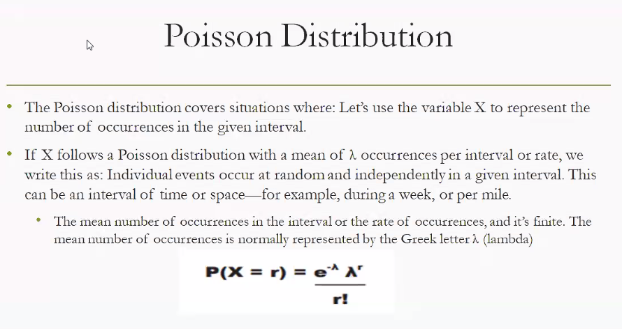

**The Poisson distribution models how often an event happens in a fixed interval of time or space — especially when events occur randomly and independently. A classic example is counting how many customers arrive at a shop per hour.**

**📊 Poisson Distribution — Real-Life Examples**

The Poisson distribution is used when:

* Events happen **independently**
* The average rate $λ$ is **constant**
* You’re counting **how many times** something happens in a fixed interval

**🔣 Formula**

$$P(X=r)=\frac{e^{-λ}⋅λ^{r}}{r!}$$

Where:

* $X$ = number of events
* $r$ = specific count you’re interested in
* $λ$ = average rate of occurrence
* $e$ = Euler’s number (~2.718)

**🧠 Practical Day-to-Day Examples**

**1. 📞 Call Center**

* **Scenario:** A call center receives an average of 10 calls per hour.
* **Question:** What’s the probability they get exactly 7 calls in the next hour?
* **Model:** Poisson with $λ=10$, $r=7$

**2. 🛒 Supermarket Checkout**

* **Scenario:** On average, 3 customers arrive at checkout every 5 minutes.
* **Use:** Predict how often 0, 1, 2, or more customers arrive in a 5-minute window.

**3. 🚗 Traffic Flow**

* **Scenario:** A toll booth sees 15 cars per hour.
* **Use:** Estimate the chance of seeing 20 cars in the next hour.

**4. 📧 Email Spam Detection**

* **Scenario:** You receive 2 spam emails per day on average.
* **Use:** What’s the chance of getting 5 spam emails tomorrow?

**5. 🏥 Hospital Emergency Room**

* **Scenario:** A hospital gets 6 emergency cases per night.
* **Use:** What’s the probability of getting exactly 4 emergencies tonight?

**🔍 Why It’s Useful**

* Helps **predict rare events** (e.g., system failures, accidents)
* Useful in **resource planning** (e.g., staffing, inventory)
* Applies to **time-based or space-based intervals**

Perfect — let’s walk through a **real-world Poisson distribution example** step by step using actual numbers and interpretation.

**📞 Example: Call Center Scenario**

**🧩 Setup**

* A call center receives **10 calls per hour** on average → $λ=10$
* We want to find the probability of receiving **exactly 7 calls** in the next hour → $r=7$

**🔣 Poisson Formula**

$$P(X=r)=\frac{e^{-λ}⋅λ^{r}}{r!}$$

Plug in values:

$$P(X=7)=\frac{e^{-10}⋅{10}^{7}}{7!}$$

Further explanation:

**You use the Poisson distribution when you want to model the probability of a certain number of events happening in a fixed interval of time or space, given that events occur randomly, independently, and at a constant average rate.**

**🧠 Key Conditions for Using Poisson**

* **Events are rare** compared to the possible opportunities.
* **Events occur independently** (one happening doesn’t affect another).
* **Average rate (λ)** of occurrence is constant over time or space.
* You’re counting **number of occurrences**, not measuring continuous values.

**📊 Practical Use Cases**

**1. 📞 Call Centers**

* **Scenario:** Average of 10 calls per hour.
* **Use:** Probability of receiving exactly 7 calls in the next hour.
* **Why Poisson?** Calls arrive randomly and independently.

**2. 🛒 Customer Arrivals**

* **Scenario:** A store averages 3 customers every 5 minutes.
* **Use:** Probability of 0 customers arriving in a 5-minute window.
* **Why Poisson?** Arrival events are random but follow a steady average rate.

**3. 🚗 Traffic & Transportation**

* **Scenario:** Toll booth averages 15 cars per hour.
* **Use:** Probability of 20 cars arriving in the next hour.
* **Why Poisson?** Cars arrive independently, but with a predictable average.

**4. 📧 Email or Spam Detection**

* **Scenario:** You get 2 spam emails per day on average.
* **Use:** Probability of receiving 5 spam emails tomorrow.
* **Why Poisson?** Emails arrive randomly but with a measurable daily average.

**5. 🏥 Hospital Emergencies**

* **Scenario:** ER averages 6 emergency cases per night.
* **Use:** Probability of exactly 4 emergencies tonight.
* **Why Poisson?** Emergencies occur independently but with a stable average rate.

**Summary**

* **Use Poisson when:** Counting discrete events in fixed intervals, with independence and constant average rate.
* **Don’t use Poisson when:** Events are not independent, rate changes over time, or you’re measuring continuous outcomes.

What do you mean by Events are not independent or rate change over time, when not to apply Poisson distribution.

**1. Events Are Not Independent**

The Poisson model assumes each event happens **independently** of others. If one event makes another more or less likely, independence is broken.

**🚫 When Poisson Fails**

* **Traffic jams:** If one car slows down, others behind it are also delayed. Arrivals are no longer independent.
* **Disease spread:** One infection increases the chance of more infections nearby. Events are dependent.
* **Social media posts:** A viral post triggers a surge of comments/likes, not independent arrivals.

**🔹 2. Rate Changes Over Time**

Poisson assumes a **constant average rate (λ)**. If the rate varies, the model doesn’t hold.

**🚫 When Poisson Fails**

* **Call centers:** Calls spike during lunch breaks and drop at night → rate is not constant.
* **Hospital ER:** More emergencies at night than during the day.
* **Retail stores:** Customer arrivals vary by hour (rush hour vs quiet times).

In these cases, a **non-homogeneous Poisson process** or another distribution (like Binomial or Normal approximations) is more appropriate.

**✅ Summary**

* **Use Poisson:** Random, independent events at a constant average rate.
* **Don’t use Poisson:** When events influence each other (dependence) or when the rate changes over time (non-constant λ).

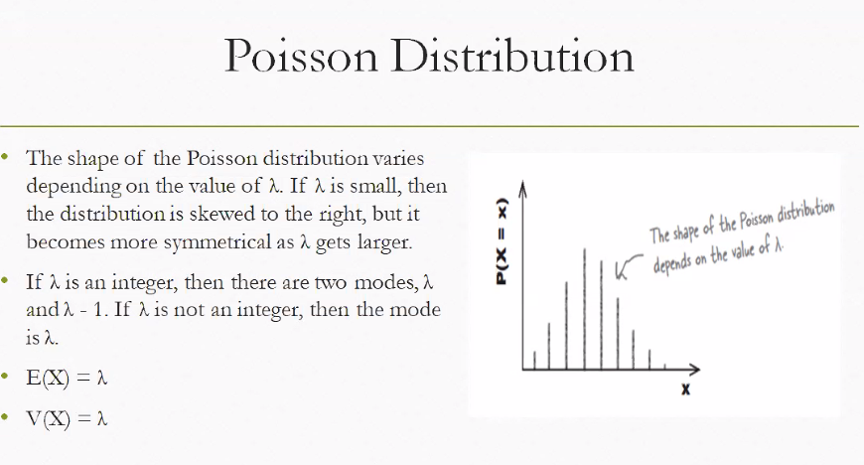

**📊 Poisson Distribution Overview**

The **Poisson distribution** models the probability of a given number of events $X$ occurring in a fixed interval of time or space, when:

* Events happen **independently**
* The average rate $λ$ is **constant**
* Events are **countable** (discrete)

**🔣 Probability Formula**

$$P(X=r)=\frac{e^{-λ}⋅λ^{r}}{r!}$$

Where:

* $r$ = number of events
* $λ$ = average rate of occurrence
* $e$ ≈ 2.718

**📐 Shape of the Distribution**

**🔹 When $λ$ is small (e.g., 1 or 2)**

* The distribution is **right-skewed**
* Most probability mass is near 0 or 1
* Example: Rare events like server crashes or power outages

**🔹 When $λ$ is large (e.g., 10 or more)**

* The distribution becomes **more symmetric**
* Starts resembling a **normal distribution**
* Example: Customer arrivals at a busy store per hour

**🎯 Mode Behavior**

* If $λ$ is an **integer**, there are **two modes**: $λ$ and $λ-1$
* If $λ$ is **not an integer**, the mode is the **floor of $λ$**

**📈 Mean and Variance**

* **Expected value (mean):**
$$E(X)=λ$$

* **Variance:**

$$V(X)=λ$$

This means the **spread** of the distribution increases with the rate.

**🧠 Real-Life Interpretation**

* If a hospital gets **2 emergencies per night**, the distribution is skewed.
* If a call center gets **20 calls per hour**, the distribution is symmetric and predictable.

Here’s a visualization showing how the shape of the Poisson distribution changes as λ increases — from skewed to symmetric.

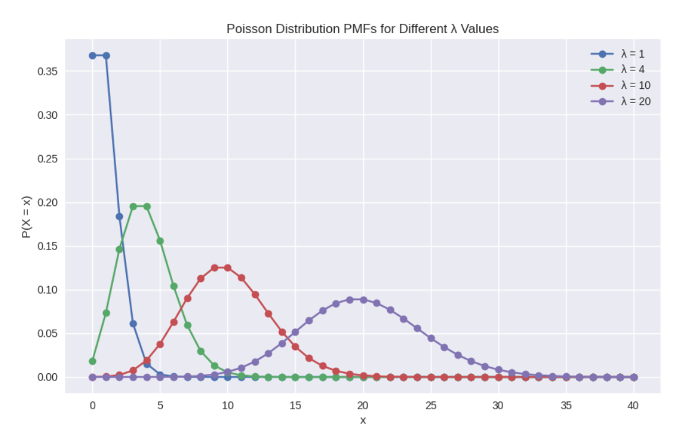

**Interpretation of the Graph**

* **λ = 1**: The distribution is **highly skewed to the right**. Most of the probability mass is near 0 and 1.
* **λ = 4**: Still skewed, but starting to spread out and flatten.
* **λ = 10**: The curve becomes **more symmetric**, resembling a bell shape.
* **λ = 20**: The distribution is **almost symmetric**, closely approximating a normal distribution.

**🧠 Why This Matters**

* **Small λ** → Use Poisson for rare events (e.g., server crashes, emergency calls).
* **Large λ** → Poisson starts behaving like a normal distribution, useful for approximations.
* **E(X) = λ and V(X) = λ** → As λ increases, both the mean and spread increase proportionally.

Here’s the visualization you asked for — showing how the **Poisson distribution’s shape changes** as the average rate $λ$ increases:

* **λ = 1** → Highly skewed to the right, most probability near 0–1
* **λ = 4** → Still skewed, but spreading out
* **λ = 10** → Much more symmetric, resembling a bell curve
* **λ = 20** → Almost symmetric, very close to a normal distribution

This illustrates the key property: **small λ → skewed, large λ → symmetric**.

Here’s the visualization you asked for — showing how the **Poisson distribution with λ = 20** closely matches a **Normal distribution with mean = 20 and variance = 20**:

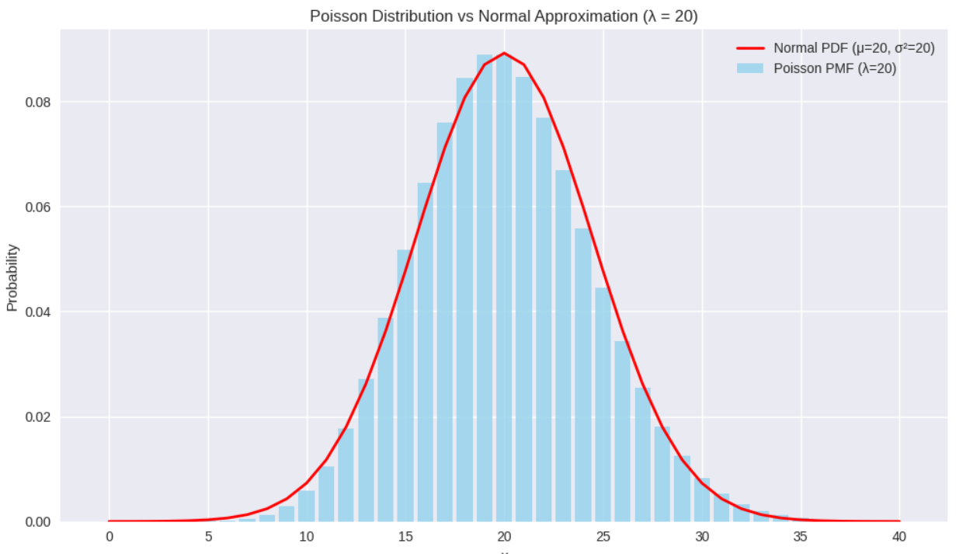

**Interpretation of the Overlay**

* The **blue bars** represent the Poisson PMF (probability mass function).
* The **red curve** represents the Normal PDF (probability density function).
* Notice how the two align very closely — this demonstrates the **Poisson-to-Normal approximation** when λ is large.

**🧠 Why This Matters**

* For **small λ**, Poisson is skewed and must be used directly.
* For **large λ (≥ 10)**, Poisson can be approximated by a Normal distribution, which is often easier to compute and analyze.
* This approximation is widely used in **statistics, quality control, and operations research** when dealing with large average event rates.

Here’s the overlay you asked for — showing how the **Poisson distribution with λ = 20** aligns with a **Normal distribution (mean = 20, variance = 20)**:

* The **Poisson PMF** (discrete probabilities) clusters around 20.
* The **Normal curve** (continuous approximation) fits almost perfectly over it.
* This demonstrates the **Poisson-to-Normal approximation**: when λ is large, Poisson behaves like Normal.

**🧠 Why This Is Important**

* For **rare events (small λ)** → Poisson is skewed and must be used directly.
* For **frequent events (large λ)** → Poisson ≈ Normal, which simplifies calculations.
* This is widely applied in **queueing theory, call centers, traffic flow, and reliability engineering**.

**Here’s the direct comparison you asked for:** For $λ=20$, the probability of exactly 20 events is **0.088835 using Poisson** and **0.089021 using Normal approximation**. The values are almost identical, showing how well the Normal distribution approximates Poisson when $λ$ is large.

**🔍 Step-by-Step Explanation**

**1. Poisson Calculation**

The formula is:

$$P(X=r)=\frac{e^{-λ}⋅λ^{r}}{r!}$$

Plugging in $λ=20,r=20$:

$$P(X=20)≈0.088835$$

**2. Normal Approximation**

For large $λ$, Poisson can be approximated by a Normal distribution with:

* Mean $μ=λ=20$
* Variance $σ^{2}=λ=20$
* Standard deviation $σ=\sqrt{20}$

We apply a **continuity correction** (since Normal is continuous, Poisson is discrete):

$$P(X=20)≈P(19.5<Y<20.5),Y∼N(20,\sqrt{20})$$

Result:

$$P(X=20)≈0.089021$$

**3. Comparison**

* **Poisson exact:** 0.088835
* **Normal approx:** 0.089021
* **Difference:** 0.000186 (negligible)

This shows that for **large λ**, Poisson ≈ Normal, making Normal a practical shortcut.

**🧠 Why This Matters**

* **Small λ (rare events):** Use Poisson directly (skewed distribution).
* **Large λ (frequent events):** Normal approximation is valid, easier to compute, and widely used in practice.
* Applications: **queueing systems, traffic flow, call centers, reliability engineering, and epidemiology.**

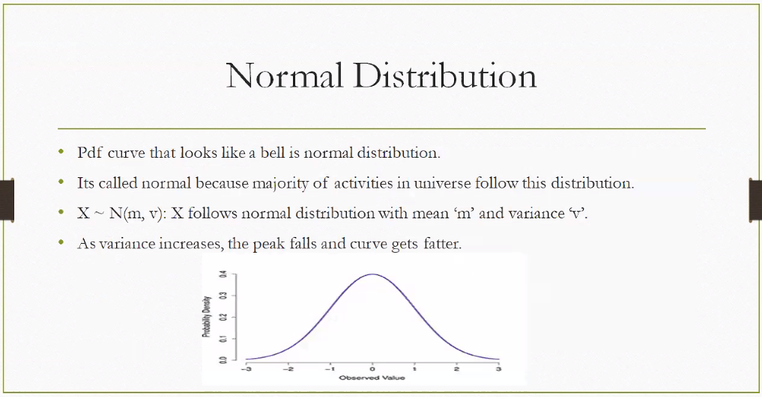

**What Is a Normal Distribution?**

The **normal distribution** is a continuous probability distribution that is **bell-shaped** and **symmetric** around its mean. It’s one of the most widely used distributions in statistics because many natural and human-made phenomena follow it.

**📘 Notation**

$$X∼N(μ,σ^{2})$$

Where:

* $X$ is the random variable
* $μ$ is the **mean** (center of the curve)
* $σ^{2}$ is the **variance** (spread of the curve)

**🔍 Key Properties**

**1. Bell-Shaped Curve**

* Highest point at the mean ($μ$)
* Symmetric: left and right sides are mirror images

**2. Mean and Variance**

* **Mean ($μ$)**: Location of the peak
* **Variance ($σ^{2}$)**: Controls the spread
  + **Higher variance** → flatter and wider curve
  + **Lower variance** → taller and narrower curve

**3. Empirical Rule (68-95-99.7 Rule)**

* 68% of data lies within ±1σ
* 95% within ±2σ
* 99.7% within ±3σ

**🧠 Why It’s Called “Normal”**

Because many real-world processes naturally follow this pattern:

* Heights of people
* Test scores
* Measurement errors
* Blood pressure
* IQ scores

**📈 Visual Insight**

* If variance increases:
  + The **peak drops**
  + The **curve spreads out**
* This reflects **greater uncertainty or variability** in the data

**Confidence Interval:**

**A confidence interval is a range of values that likely contains the true value of a population parameter, such as a mean or proportion, based on sample data. It reflects the uncertainty in estimation and is associated with a confidence level like 95% or 99%.**

**📘 Definition**

In statistics, a **confidence interval (CI)** gives an estimated range of values which is likely to include an unknown population parameter. It’s calculated from sample data and expresses how confident we are that the true value lies within that range.

**🔣 Notation**

$$\text{CI}=\overset{ˉ}{x}±Z⋅\frac{σ}{\sqrt{n}}$$

Where:

* $\overset{ˉ}{x}$ = sample mean
* $Z$ = Z-score (based on confidence level)
* $σ$ = population standard deviation
* $n$ = sample size

**🎯 Confidence Level**

* **95% CI** means: If we repeated the sampling process 100 times, about 95 of those intervals would contain the true population value.
* Common levels: **90%, 95%, 99%**

**🧠 Real-Life Examples**

**1. 📊 Average Height**

“We are 95% confident that the average height of adult males is between 168 cm and 174 cm.”

**2. 🛒 Customer Satisfaction**

“Survey results show 80% satisfaction with a 95% CI of [76%, 84%].”

**3. 🧪 Medical Trials**

“The drug reduces blood pressure by 12 mmHg, with a 95% CI of [10, 14].”

**🔍 Interpretation Tips**

* A **wider interval** means more uncertainty.
* A **narrower interval** means more precision.
* Increasing the **sample size** or reducing variability narrows the interval.
* **Confidence level ≠ probability** that the interval contains the true value — it reflects long-run frequency.

**❌ Common Misunderstandings**

* Saying “there’s a 95% chance the true value is in this interval” is incorrect.
* The interval either **does** or **does not** contain the true value — the confidence level refers to the method’s reliability over repeated samples.

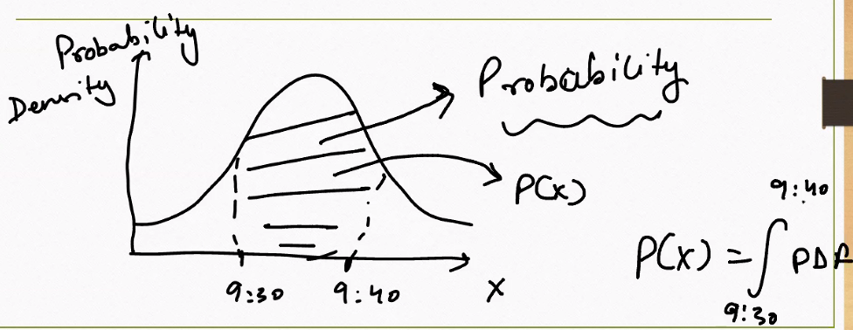

* Area under curve is calculated using Integration.

Absolutely, Sachin — this image beautifully illustrates the **core idea behind probability density functions (PDFs)** in continuous probability distributions like the **normal distribution**.

**📊 What the Graph Shows**

* The **bell-shaped curve** is a **probability density function (PDF)** — often a normal distribution.
* The **x-axis** represents a continuous variable (like time, height, or temperature).
* The **y-axis** shows **probability density**, not actual probability.
* The **shaded area between 9:30 and 9:40** represents the **probability** that the variable falls within that interval.

**🔣 Key Concept**

For continuous distributions:

$$P(a≤X≤b)=\int_{a}^{b}{}\text{PDF}(x) dx$$

* You **don’t get probability from a single point** (e.g., $P(X=9:35)=0$)
* You get probability from the **area under the curve** between two points — like 9:30 and 9:40.

**🧠 Real-Life Analogy**

Imagine you’re tracking when customers arrive at a store:

* The curve shows how likely arrivals are at different times.
* The shaded area from 9:30 to 9:40 tells you the **chance a customer arrives in that window**.

**🔍 Why This Matters**

* In **continuous distributions**, probability = **area under the curve**
* The **PDF itself isn’t probability**, but it helps compute it
* This is foundational in **statistics, machine learning, and risk modeling**

**The probability of a point estimate is Zero. That is why we need to calculate the probability density under a range.**

Exactly right, Sachin — you’ve nailed a foundational concept in continuous probability theory. Let’s build on that with a structured explanation:

**🎯 Why Probability of a Point Is Zero**

In **continuous distributions** (like the normal distribution), the probability of a random variable taking **exactly one value** is:

$$P(X=x)=0$$

This is because:

* There are **infinitely many possible values** in any interval.
* The probability is spread across all those values.
* So, the **area under the curve at a single point** is zero.

**📊 What We Use Instead: Probability Density**

We use a **probability density function (PDF)** to describe how likely values are near a point — but not at the point itself.

**🔣 To get actual probability:**

$$P(a≤X≤b)=\int_{a}^{b}{}\text{PDF}(x) dx$$

This integral gives the **area under the curve** between $a$ and $b$, which is the actual probability.

**🧠 Real-Life Analogy**

Imagine measuring the exact time a customer walks into a store:

* The chance they arrive at **exactly 9:35:00.000000…** is zero.
* But the chance they arrive **between 9:30 and 9:40** is measurable — that’s the area under the curve.

**🔍 Why This Matters**

* In **discrete distributions** (like Poisson or Binomial), you can assign probability to exact values.
* In **continuous distributions**, you must use **intervals** and **integrals**.

**📊 Why Probability of a Point = 0**

* In **continuous distributions** (like Normal, Exponential, Uniform), the random variable can take infinitely many values.
* The probability at a single exact value (say $X=9.35$) is **zero**, because the area under the curve at one point has no width.
* Instead, we measure probability over a **range**:

$$P(a≤X≤b)=\int_{a}^{b}{}f(x) dx$$

where $f(x)$ is the PDF.

**🔍 Probability Density vs Probability**

* **PDF (density):** Height of the curve at a point. It tells us how “dense” probability is around that value.
* **Probability:** Area under the curve between two bounds. This is what we can actually measure.

Example:

* PDF at 9:35 may be high, but probability of “exactly 9:35” = 0.
* Probability of “between 9:30 and 9:40” = shaded area under the curve.

**🧠 Real-Life Examples**

1. **Arrival Times** Customers arrive at a store. Probability of arriving at exactly 9:35 = 0. Probability of arriving between 9:30–9:40 = area under PDF in that interval.
2. **Heights** Probability someone is *exactly* 170.000 cm tall = 0. Probability someone is between 170–175 cm = area under PDF.
3. **Exam Scores** Probability of scoring exactly 80.000 = 0. Probability of scoring between 80–85 = area under PDF.

**📐 Connection to Confidence Intervals**

Confidence intervals are essentially **ranges under the curve** where we expect the true parameter to lie.

* Example: 95% CI for mean height = [168, 174].
* This means the **area under the curve between 168–174 covers 95% of probability mass**.

**📈 Distribution Shapes**

* **Normal distribution:** Symmetric bell curve, probabilities found by area under curve.
* **Poisson distribution:** Discrete, so exact values *do* have probability.
* **Exponential distribution:** Continuous, skewed, often used for waiting times.

**✅ Key Takeaways**

* **Point probability = 0** in continuous distributions.
* **Intervals matter** → probability = area under PDF.
* **Confidence intervals** are ranges that capture a certain proportion of probability mass.
* **Discrete vs continuous**: discrete → exact values have probability; continuous → only ranges matter.

**One more Example :**

**The probability that a person’s height lies between 165 cm and 175 cm, given a normal distribution with mean = 170 cm and standard deviation = 5 cm, is about 0.6827 (≈ 68%).**

This is a classic demonstration of the **empirical rule**: in a normal distribution, about 68% of values fall within one standard deviation of the mean.

**📊 Step-by-Step Explanation**

1. **Parameters**
   * Mean ($μ$) = 170 cm
   * Standard deviation ($σ$) = 5 cm
   * Interval = [165, 175] → this is exactly $μ±1σ$
2. **Formula**

$$P(165≤X≤175)=\int_{165}^{175}{}f(x) dx$$

where $f(x)$ is the normal PDF.

1. **Result** Using the cumulative distribution function (CDF):

$$P=Φ(\frac{175-170}{5})-Φ(\frac{165-170}{5})$$

$$=Φ(1)-Φ(-1)≈0.8413-0.1587=0.6826$$

**📈 Visualization**

Here’s the normal distribution curve with the shaded area between 165 and 175 cm:

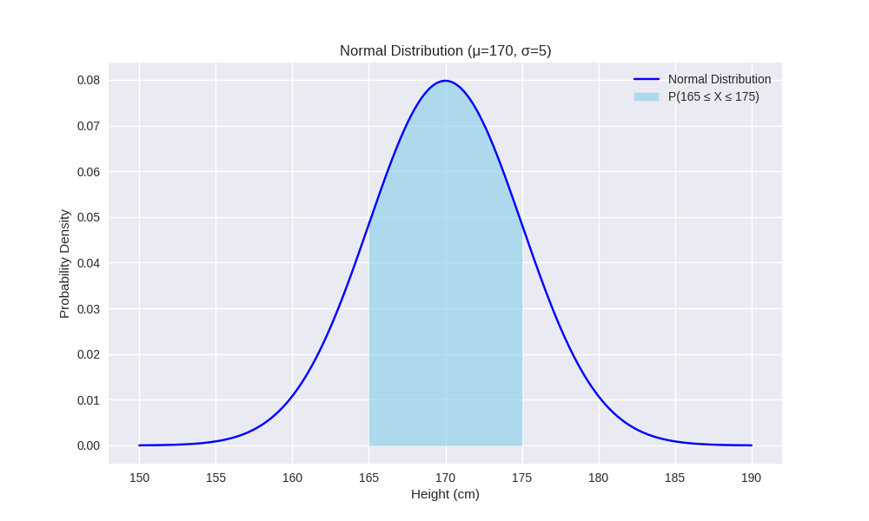

**🧠 Interpretation**

* About **68% of people** (if heights follow this distribution) are between 165–175 cm.
* This is the **empirical rule**:
  + 68% within ±1σ
  + 95% within ±2σ
  + 99.7% within ±3σ

Car Example :

let’s translate the **probability density and confidence interval idea** into something very tangible: **car speed, time, and distance** 🚗.

**📊 Probability Density in Car Terms**

Think of a car’s speed as a **random variable**.

* At any exact speed (say exactly 60.000 km/h), the probability is **zero** — because speed is continuous.
* But the **probability density function (PDF)** tells us how likely speeds are *around* that value.

👉 To get actual probability, we look at a **range of speeds** (like 55–65 km/h), which is the **area under the curve**.

**🧠 Example: Car Speed**

* Suppose your car’s average speed on a highway is **60 km/h**, with some variation.
* The distribution of speeds might look like a **bell curve** (normal distribution).
* Probability of being **exactly 60 km/h** = 0.
* Probability of being **between 55 and 65 km/h** = shaded area under the curve in that interval.

This is just like saying:

$$P(55≤\text{Speed}≤65)=\int_{55}^{65}{}f(x) dx$$

**🕒 Example: Travel Time**

* You usually take **30 minutes** to drive to work, but sometimes it’s faster or slower.
* The distribution of travel times is continuous.
* Probability of arriving at **exactly 30 minutes** = 0.
* Probability of arriving between **28–32 minutes** = area under the curve in that range.

**📏 Example: Distance Covered**

* If you drive for 1 hour, the distance depends on your speed.
* Probability of covering **exactly 60 km** = 0.
* Probability of covering **between 55–65 km** = area under the curve.

**🔍 Confidence Interval Analogy**

Think of a **confidence interval** as the range of speeds or times you’re “confident” about:

* **68% confidence interval**: Between 55–65 km/h (most common speeds).
* **95% confidence interval**: Between 50–70 km/h (almost all speeds).
* **99.7% confidence interval**: Between 45–75 km/h (extreme but possible).

✅ So in car terms:

* **PDF curve** = how likely different speeds are.
* **Probability** = area under the curve between two speeds/times/distances.
* **Confidence interval** = the range where you expect most of your trips to fall.

**draw a graph with car speed distribution** (say mean = 60 km/h, σ = 5 km/h) and shade the 55–65 km/h interval so you can see the analogy visually?

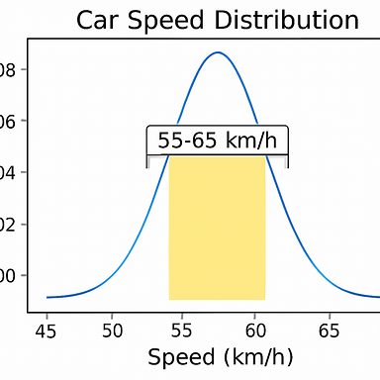

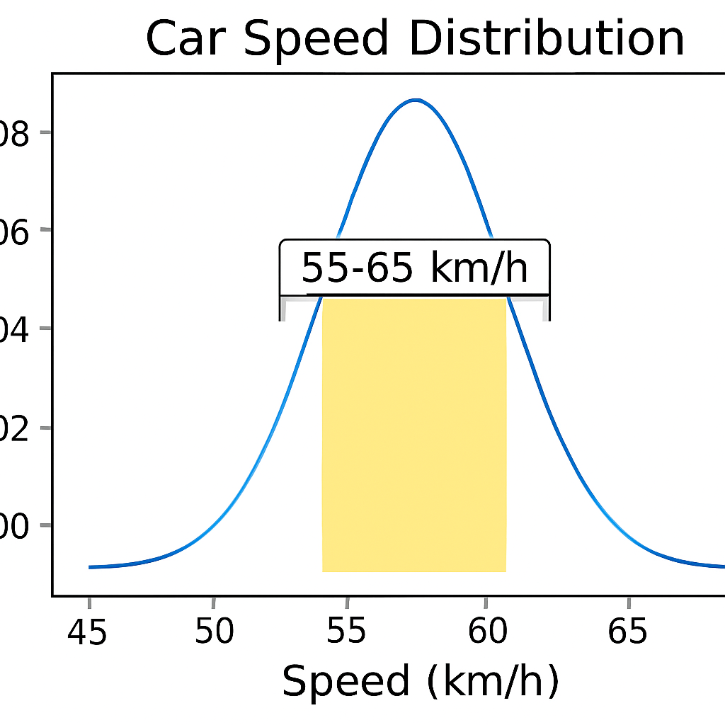

Here’s the visualization of the **car speed distribution** you asked for — the bell-shaped curve shows speeds centered at 60 km/h, and the shaded area between **55–65 km/h** represents the probability of driving within that range.

This shaded region is exactly like the probability interval we discussed earlier:

* The curve itself shows **density** (likelihood around each speed).
* The **area under the curve** between 55–65 km/h is the actual probability.
* In normal distribution terms, this interval is roughly **68% of all trips** (the empirical rule: ±1σ).

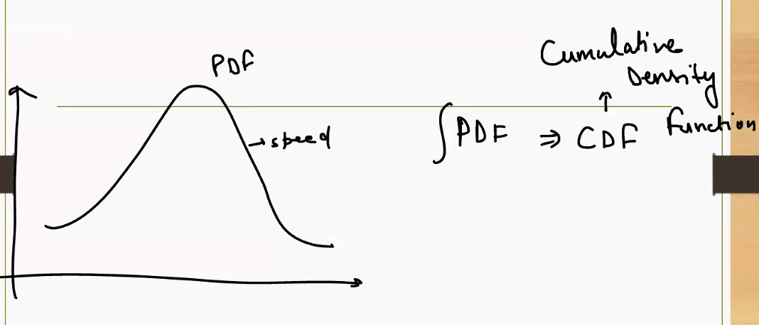

This diagram beautifully illustrates the relationship between a **Probability Density Function (PDF)** and a **Cumulative Distribution Function (CDF)** — especially in the context of something intuitive like **car speed**.

**📊 What Is a PDF?**

* The **PDF (Probability Density Function)** shows how likely a value is *around* a specific point.
* For example, if car speeds are normally distributed around 60 km/h, the PDF curve tells you:
  + Speeds near 60 km/h are **more likely** (higher peak).
  + Speeds far from 60 km/h are **less likely** (lower tails).
* But remember: **probability at a single speed (e.g., exactly 60 km/h) is zero** — we need a range.

**📈 What Is a CDF?**

* The **CDF (Cumulative Distribution Function)** is the **accumulated probability** up to a certain point.
* It answers: “What’s the probability that the car is going **slower than or equal to** a certain speed?”
* Mathematically:
$$\text{CDF}(x)=\int_{-∞}^{x}{}\text{PDF}(t) dt$$

* So, if you want to know the probability that your car is going ≤ 65 km/h, you’d compute the **area under the PDF curve from the left up to 65**.

**🚗 Car Speed Analogy**

* **PDF:** Tells you how likely different speeds are. → Peak at 60 km/h means that’s the most common speed.
* **CDF:** Tells you the probability of being **at or below** a certain speed. → CDF at 65 km/h might be 0.84, meaning 84% of trips are at or below 65 km/h.

**🔁 Summary**

| **Concept** | **PDF** | **CDF** |
| --- | --- | --- |
| Meaning | Likelihood density at each value | Accumulated probability up to a value |
| Value at a point | Not a probability | Is a probability |
| Shape | Bell curve (for normal) | S-shaped curve |
| Example | “How likely is 60 km/h?” | “What’s the chance of ≤ 65 km/h?” |

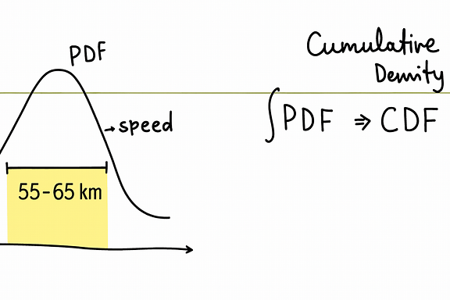

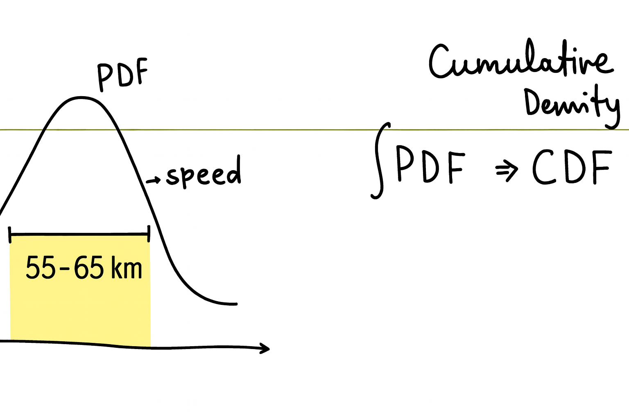

Here’s the visual comparison of **PDF vs CDF for car speeds**:

* On the **left**, the **PDF (Probability Density Function)** shows the likelihood of different speeds — peaking at 60 km/h. The shaded area between 55–65 km/h represents the probability of driving within that range.
* On the **right**, the **CDF (Cumulative Distribution Function)** shows the accumulated probability up to a given speed. For example, the value at 65 km/h tells you the probability of driving at or below that speed.

This illustrates how:

* **PDF gives density** (how likely each speed is),
* **CDF gives cumulative probability** (how much probability has accumulated up to a speed).

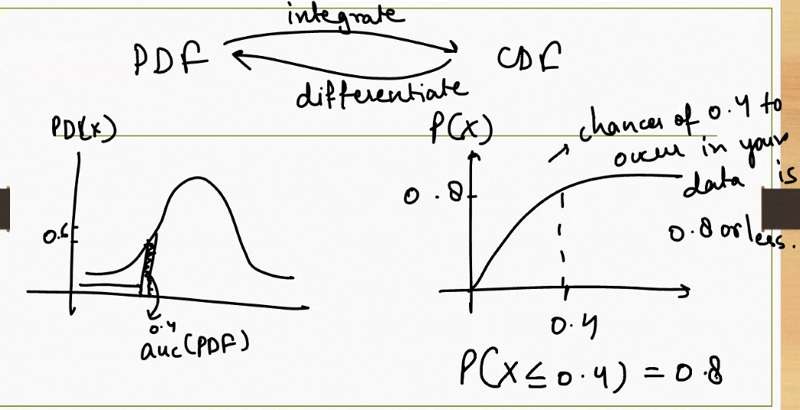

This diagram beautifully captures the **mathematical relationship between PDF and CDF** — and it’s a perfect extension of what we’ve been discussing with car speed, probability, and confidence intervals.

**📊 PDF vs CDF: Core Relationship**

**🔹 PDF (Probability Density Function)**

* Describes **how likely** a value is *around* a point.
* It’s the **curve** you see in the left graph — bell-shaped for normal distributions.
* You **can’t get probability from a single point**, but you can get it from an **interval** (area under the curve).

**🔹 CDF (Cumulative Distribution Function)**

* Describes the **total probability** accumulated **up to** a point.
* It’s the **area under the PDF curve** from the left up to that point.
* The right graph shows this: at $x=0.4$, the CDF value is 0.8 → meaning:

$$P(X≤0.4)=0.8$$

**🔁 Integration and Differentiation**

* **To get CDF from PDF**:

$$\text{CDF}(x)=\int_{-∞}^{x}{}\text{PDF}(t) dt$$

→ You **integrate** the PDF.

* **To get PDF from CDF**:

$$\text{PDF}(x)=\frac{d}{dx}\text{CDF}(x)$$

→ You **differentiate** the CDF.

This is why the diagram shows arrows:

* “Integrate” from PDF → CDF
* “Differentiate” from CDF → PDF

**🧠 Real-Life Analogy: Car Speed**

* **PDF:** How likely is a car to be going at a certain speed? → Peak at 60 km/h means that’s the most common speed.
* **CDF:** What’s the chance the car is going **at or below** 65 km/h? → You add up all the probability from the left up to 65.

**✅ Summary Table**

| **Concept** | **PDF** | **CDF** |
| --- | --- | --- |
| Meaning | Likelihood density | Accumulated probability |
| Value at a point | Not a probability | Is a probability |
| Shape | Bell curve | S-shaped curve |
| Math | Derivative of CDF | Integral of PDF |
| Example | “How likely is 60 km/h?” | “Chance of ≤ 65 km/h” |

**🎯 What Does “Probability of a Point Estimate Is Zero” Mean?**

In **continuous probability distributions** (like the normal distribution), the probability of a random variable taking **exactly one value** — say, exactly 60.000000 km/h — is **zero**.

Why?

Because:

* There are **infinitely many possible values** in any interval.
* The probability is **spread out** across all those values.
* So, the **area under the curve at a single point** has no width → no measurable probability.

Mathematically:

$$P(X=x)=0\text{(for continuous distributions)}$$

**📊 What We Use Instead: Probability Over an Interval**

To get meaningful probability, we look at a **range**:

$$P(a≤X≤b)=\int_{a}^{b}{}f(x) dx$$

Where:

* $f(x)$ is the **probability density function (PDF)**
* The integral gives the **area under the curve** between $a$ and $b$

**🚗 Car Speed Analogy**

Imagine your car’s speed varies around 60 km/h:

* The chance of driving at **exactly 60.000000 km/h** is zero.
* But the chance of driving **between 59.5 and 60.5 km/h** is measurable — that’s the area under the curve.

**📈 Visual Insight**

* The **PDF curve** shows how likely values are *around* a point.
* The **area under the curve** between two points gives actual probability.
* That’s why we say: **point estimate has zero probability**, but **intervals have measurable probability**.

**🧠 Why This Matters**

* In **continuous distributions**, we never ask “What’s the probability of exactly X?”
* We ask: “What’s the probability that X falls within a range?”
* This is foundational for **confidence intervals**, **hypothesis testing**, and **real-world modeling**.

CDF is integration of PDF :

Great, Sachin — let’s break this down carefully and connect it to the car speed analogy we’ve been using.

**📊 Relationship Between PDF and CDF**

**1. PDF (Probability Density Function)**

* Describes how likely values are *around* a point.
* It’s the **curve** (often bell-shaped for normal distributions).
* Example: Car speed distribution centered at 60 km/h — the PDF shows which speeds are more common.

**2. CDF (Cumulative Distribution Function)**

* Describes the **total probability accumulated up to a point**.
* It’s the **area under the PDF curve** from the left up to that point.
* Example: Probability that your car is going **≤ 65 km/h** is the area under the PDF curve from 0 to 65.

**🔣 Mathematical Connection**

$$\text{CDF}(x)=\int_{-∞}^{x}{}\text{PDF}(t) dt$$

* **Integration** of the PDF gives the CDF.
* The CDF is always between 0 and 1 (since it represents probability).
* It’s a non-decreasing function (probability accumulates as you move right).

And conversely:

$$\text{PDF}(x)=\frac{d}{dx}\text{CDF}(x)$$

* **Differentiation** of the CDF gives back the PDF.

**🚗 Car Speed Analogy**

* **PDF:** At 60 km/h, the curve is highest → most likely speed.
* **CDF:** At 65 km/h, the CDF might equal 0.84 → meaning 84% of trips are at or below 65 km/h.

So:

* PDF = “likelihood density at each speed.”
* CDF = “chance of being at or below a speed.”

**✅ Key Takeaways**

* **PDF** gives the *shape* of likelihood.
* **CDF** gives the *accumulated probability*.
* Integration links them: area under PDF = probability up to that point.
* Differentiation reverses it: slope of CDF = PDF.

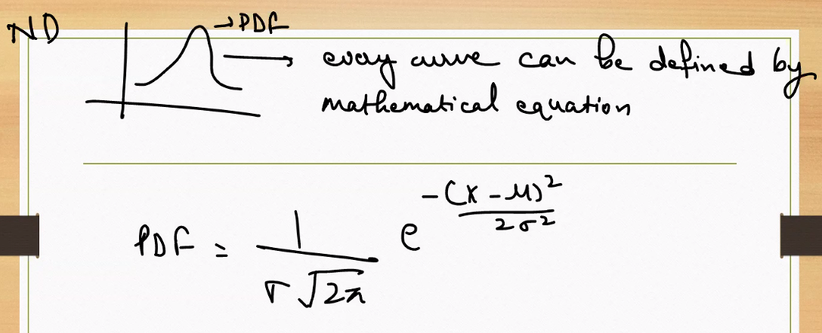

Absolutely, Sachin — this handwritten note captures the **mathematical essence of the normal distribution’s PDF**. Let’s break it down clearly and connect it to everything we’ve discussed.

**📊 What You’re Seeing**

* The **bell-shaped curve** labeled “PDF” is the **Probability Density Function** of a **Normal Distribution (ND)**.
* The note says: “Every curve can be defined by a mathematical equation” — and this is the exact equation for the normal distribution’s PDF.

**🔣 The Formula Explained**

$$\text{PDF}(x)=\frac{1}{σ\sqrt{2π}}⋅e^{-\frac{(x-μ)^{2}}{2σ^{2}}}$$

Where:

* $x$ = the value of the random variable (e.g., car speed)
* $μ$ = mean (center of the distribution)
* $σ$ = standard deviation (spread of the distribution)
* $e$ = Euler’s number (≈ 2.718), used in exponential decay

**🧠 What It Means**

* The formula gives the **height of the curve** at any point $x$.
* It’s **not a probability**, but a **density** — you need to integrate it over a range to get actual probability.
* The curve is **symmetric** around the mean ($μ$), and the spread is controlled by $σ$.

**🚗 Car Speed Analogy**

Let’s say:

* Mean speed = 60 km/h
* Standard deviation = 5 km/h

Then:

* The PDF tells you how likely it is to be *around* 60 km/h.
* The peak of the curve is at 60.
* Speeds like 55 or 65 have lower density.
* To find the probability of driving between 55–65 km/h, you’d integrate this formula over that interval.

**🔁 Connection to CDF**

As shown in your earlier diagrams:

* **CDF(x)** = area under the PDF curve from $-∞$ to $x$
* You get it by **integrating** this PDF formula

**Z-Score :**

Excellent question, Sachin — the **Z-score** is the bridge between raw data and the standard normal distribution. It’s how we **standardize** values so they can be interpreted using the **normal distribution’s PDF and CDF**.

**🔣 What Is a Z-Score?**

The **Z-score** tells you how many standard deviations a value is from the mean.

$$Z=\frac{X-μ}{σ}$$

Where:

* $X$ = raw value (e.g., car speed)
* $μ$ = mean of the distribution
* $σ$ = standard deviation

**🧠 Why It Matters**

* Z-scores **transform any normal distribution** into the **standard normal distribution** (mean = 0, σ = 1).
* Once you have a Z-score, you can use **standard normal tables** or the **CDF of the standard normal distribution** to find probabilities.

**🚗 Car Speed Example**

Let’s say:

* Mean speed = 60 km/h
* Standard deviation = 5 km/h
* You want to know how unusual 70 km/h is

Then:

$$Z=\frac{70-60}{5}=2$$

This means:

* 70 km/h is **2 standard deviations above the mean**
* Using the **CDF**, $P(X≤70)$ ≈ 0.9772 → so 97.72% of trips are at or below 70 km/h

**📊 How It Connects to PDF and CDF**

* **PDF**: You can plug the Z-score into the standard normal PDF formula to get the **density** at that point.
* **CDF**: You can plug the Z-score into the standard normal CDF to get the **probability** up to that point.

**✅ Summary**

| **Concept** | **Role** |
| --- | --- |
| Z-score | Standardizes raw data |
| PDF | Gives density at Z |
| CDF | Gives cumulative probability up to Z |
| Use | Compare values across different distributions, compute probabilities, define confidence intervals |

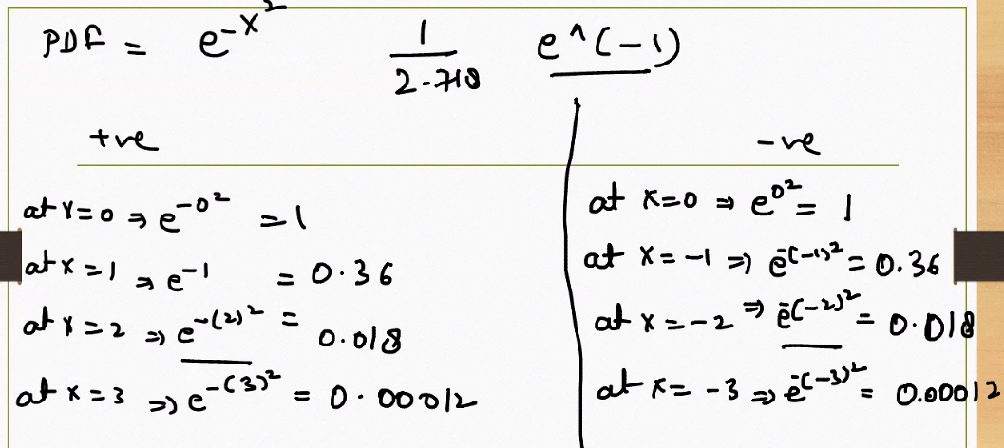

This handwritten note beautifully illustrates the **core shape and symmetry of the normal distribution’s PDF**, especially the role of the exponential function $e^{-x^{2}}$. Let’s break it down step by step:

**📊 The Formula in Focus**

The simplified version shown is:

$$\text{PDF}(x)=e^{-x^{2}}$$

This is the **core exponential component** of the full normal distribution formula:

$$\text{PDF}(x)=\frac{1}{σ\sqrt{2π}}⋅e^{-\frac{(x-μ)^{2}}{2σ^{2}}}$$

In the simplified form:

* It assumes $μ=0$ and $σ=1$ → this is the **standard normal distribution**.
* The exponential part $e^{-x^{2}}$ controls the **shape** of the bell curve.

**🔁 Symmetry of the Curve**

The note shows values for both **positive and negative x**:

|  |  |
| --- | --- |
| 0 | 1.000 |
| ±1 | 0.3679 |
| ±2 | 0.0183 |
| ±3 | 0.00012 |

This demonstrates:

* The curve is **perfectly symmetric** around $x=0$.
* As you move away from the center, the value of the PDF **drops sharply**.
* This is why the normal distribution has **thin tails** — extreme values are rare.

**🧠 Why This Matters**

* The exponential decay $e^{-x^{2}}$ ensures that most probability mass is **concentrated near the mean**.
* It also explains why the normal distribution is **bell-shaped** and why values far from the mean are **exponentially less likely**.

**🚗 Car Speed Analogy**

Imagine:

* Mean speed = 60 km/h
* Standard deviation = 5 km/h

Then:

* Speeds near 60 km/h have **high density** (e.g., 60 → PDF ≈ 1)
* Speeds like 70 or 50 → PDF ≈ 0.3679
* Speeds like 80 or 40 → PDF ≈ 0.0183
* Speeds like 90 or 30 → PDF ≈ 0.00012

This shows how **rare extreme speeds** are in a normal distribution.

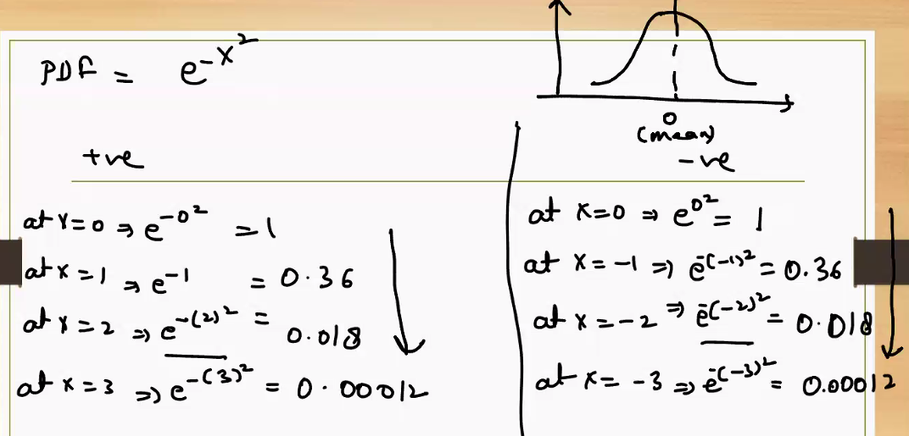

This note beautifully illustrates the **symmetry and decay behavior of the normal distribution’s exponential core**, specifically the function:

$$\text{PDF}(x)=e^{-x^{2}}$$

Let’s break it down clearly:

**📊 What This Function Represents**

This is a **simplified version** of the normal distribution’s probability density function (PDF), assuming:

* Mean $μ=0$
* Standard deviation $σ=1$

In full form, the normal PDF is:

$$f(x)=\frac{1}{\sqrt{2π}}⋅e^{-\frac{x^{2}}{2}}$$

But the note focuses on the **core exponential term $e^{-x^{2}}$** , which controls the **shape** of the bell curve.

**🔁 Symmetry Around the Mean**

The values shown demonstrate that:

|  |  |
| --- | --- |
| 0 | 1.000 |
| ±1 | 0.3679 |
| ±2 | 0.0183 |
| ±3 | 0.00012 |

This shows:

* The curve is **perfectly symmetric** around $x=0$
* As you move away from the mean, the value of the PDF **drops exponentially**
* This is why the normal distribution has **thin tails** — extreme values are very unlikely

**🧠 Why This Matters**

* The exponential decay ensures that most probability mass is **concentrated near the mean**
* It also explains why the normal distribution is **bell-shaped**
* The symmetry means that values equally distant from the mean (e.g., ±1) have **equal likelihood**

**🚗 Car Speed Analogy**

Imagine:

* Mean speed = 60 km/h
* Standard deviation = 5 km/h

Then:

* Speeds near 60 km/h (like 59 or 61) have **high density**
* Speeds like 70 or 50 → much lower density
* Speeds like 80 or 40 → extremely rare

This exponential decay explains why **most trips cluster around the average speed**, and **extreme speeds are rare**.

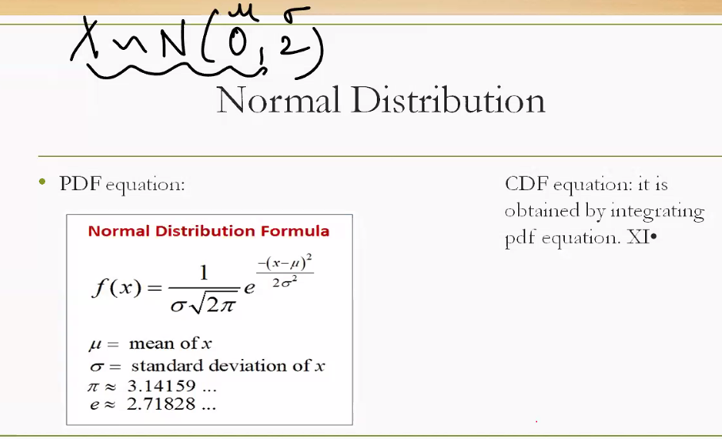

**Normal Distribution Notation**

At the top:

$$X∼N(0,2)$$

This means:

* $X$ is a random variable
* It follows a **normal distribution**
* With **mean $μ=0$**
* And **standard deviation $σ=2$**

**🔣 PDF: Probability Density Function**

The formula shown is:

$$f(x)=\frac{1}{σ\sqrt{2π}}⋅e^{-\frac{(x-μ)^{2}}{2σ^{2}}}$$

This defines the **bell-shaped curve** of the normal distribution.

**Components:**

* $μ$: Mean — center of the curve
* $σ$: Standard deviation — controls the spread
* $e$: Euler’s number ≈ 2.718
* $π$: Pi ≈ 3.14159

**What It Does:**

* Gives the **density** at any point $x$
* Not a probability by itself — you must **integrate** it over an interval to get probability

**📈 CDF: Cumulative Distribution Function**

The slide says:

“It is obtained by integrating the PDF equation.”

That’s exactly right:

$$\text{CDF}(x)=\int_{-∞}^{x}{}f(t) dt$$

**What It Does:**

* Gives the **total probability** up to point $x$
* For example: $\text{CDF}(2)=P(X≤2)$

**🧠 Why This Matters**

* The **PDF** tells you how likely values are *around* a point
* The **CDF** tells you the **probability of being at or below** a point
* Together, they let you compute probabilities, confidence intervals, and Z-scores

**🚗 Car Speed Analogy (with $X∼N(60,5)$)**

* PDF at 60 km/h → highest density (most common speed)
* CDF at 65 km/h → probability of driving ≤ 65 km/h
* Z-score for 70 km/h → $Z=\frac{70-60}{5}=2$, then use CDF to find probability



This image compares two **normal distributions** with the same mean but **different variances**, helping you understand how **spread** affects the shape and density of the distribution. Let’s break it down:

**📊 What the Notation Means**

* **Left side:**

$$X∼N(0,2)$$

→ Mean $μ=0$, Standard deviation $σ=2$

* **Right side:**

$$X∼N(0,4)$$

→ Mean $μ=0$, Standard deviation $σ=4$

**🔍 Dense vs Sparse Distributions**

**🔹 Dense (σ = 2)**

* The curve is **narrower and taller**
* Data points are **closely packed** around the mean
* Most values fall within a **tight range** (e.g., -4 to +4)

**🔹 Sparse (σ = 4)**

* The curve is **wider and flatter**
* Data points are **more spread out**
* Values are more likely to fall **farther from the mean**

**🧠 Why This Matters**

* **Standard deviation (σ)** controls the **spread** of the distribution
* A **larger σ** means more variability → data is more dispersed
* A **smaller σ** means less variability → data is tightly clustered

**🚗 Car Speed Analogy**

Imagine two drivers:

* Driver A: average speed = 60 km/h, σ = 5 → consistent driver
* Driver B: average speed = 60 km/h, σ = 15 → erratic driver

Both have the same average, but:

* Driver A’s speeds are tightly packed around 60
* Driver B’s speeds vary widely — from 30 to 90 km/h

**✅ Summary Table**

| **Distribution** | **Mean (μ)** | **Std Dev (σ)** | **Shape** | **Spread** |
| --- | --- | --- | --- | --- |
| Dense | 0 | 2 | Tall, narrow | Low variability |
| Sparse | 0 | 4 | Flat, wide | High variability |

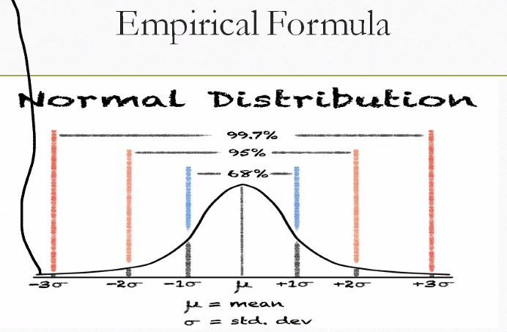

**📊 What Is the Empirical Rule?**

Also known as the **68-95-99.7 Rule**, it describes how data is spread around the mean in a normal distribution.

**Here's what it says:**

| **Interval** | **Range** | **% of Data** |
| --- | --- | --- |
| ±1σ | μ ± 1σ | ~68% |
| ±2σ | μ ± 2σ | ~95% |
| ±3σ | μ ± 3σ | ~99.7% |

So if your data follows a normal distribution:

* **68%** of values fall within **1 standard deviation** of the mean
* **95%** fall within **2 standard deviations**
* **99.7%** fall within **3 standard deviations**

**🧠 Why It Matters**

This rule helps you:

* Quickly estimate **how typical or extreme** a value is
* Understand **confidence intervals** and **Z-scores**
* Make decisions in **quality control, forecasting, and risk analysis**

**🚗 Car Speed Analogy**

Let’s say:

* Mean speed $μ=60$ km/h
* Standard deviation $σ=5$ km/h

Then:

* **68%** of trips are between **55–65 km/h**
* **95%** are between **50–70 km/h**
* **99.7%** are between **45–75 km/h**

So if someone drives at 80 km/h, they’re in the **extreme 0.3% tail** — very rare!

**🔁 Connection to PDF and CDF**

* The **PDF** gives the bell-shaped curve
* The **CDF** lets you compute the exact probability of being below or above a value
* The **Empirical Rule** gives you a quick estimate without needing to compute integrals

How is IQR related here :

Great question, Sachin — the **Interquartile Range (IQR)** is a powerful way to understand **spread and variability**, especially when comparing it to the **standard deviation and the Empirical Rule** in a normal distribution. Let’s break it down:

**📊 What Is IQR?**

The **Interquartile Range (IQR)** measures the spread of the **middle 50% of data**:

$$\text{IQR}=Q_{3}-Q_{1}$$

Where:

* $Q_{1}$ = 25th percentile (lower quartile)
* $Q_{3}$ = 75th percentile (upper quartile)

So IQR tells you how wide the central chunk of your data is — **less sensitive to outliers** than standard deviation.

**📈 IQR in a Normal Distribution**

In a **perfect normal distribution**:

$Q_{1}≈μ-0.674σ$

$Q_{3}≈μ+0.674σ$

* So:

$$\text{IQR}≈1.349σ$$

This means:

* IQR and standard deviation are **linearly related** in normal distributions
* You can estimate one from the other if the data is normal

**🔁 Comparing IQR and Empirical Rule**

| **Metric** | **Covers** | **Robust to Outliers** | **Use Case** |
| --- | --- | --- | --- |
| IQR | Middle 50% (Q1–Q3) | ✅ Yes | Box plots, skewed data |
| ±1σ | ~68% of data | ❌ No | Normal distributions |
| ±2σ | ~95% of data | ❌ No | Confidence intervals |

So:

* **IQR** is great for **non-normal or skewed data**
* **Standard deviation and Empirical Rule** are ideal for **normal distributions**

**🚗 Car Speed Analogy**

Imagine your car speeds follow a normal distribution:

* Mean = 60 km/h, σ = 5 km/h
* Then:
 $Q_{1}≈60-3.37=56.63$

 $Q_{3}≈60+3.37=63.37$

+ IQR ≈ 6.74 km/h

This tells you that **half your trips fall between 56.63 and 63.37 km/h** — a tight, central range.

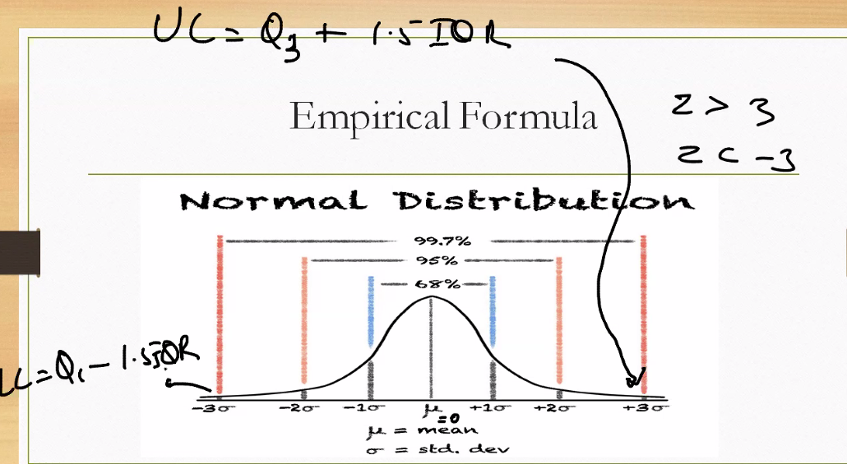

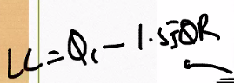



This pair of formulas relates to **detecting outliers using the Interquartile Range (IQR)** — a robust method often used in box plots and exploratory data analysis.

**📊 Formula Breakdown**

**1. Upper Cutoff (UC)**

$$UC=Q_{3}+1.5⋅IQR$$

* $Q_{3}$: 75th percentile (upper quartile)
* $IQR=Q_{3}-Q_{1}$: spread of the middle 50% of data
* Anything **above UC** is considered a **high-end outlier**

**2. Lower Cutoff (LC)**

The second formula appears to be a variation of the lower bound:

$$LC=Q_{1}-1.5⋅IQR$$

(Your image shows a slightly different notation, but this is the standard form.)

* $Q_{1}$: 25th percentile (lower quartile)
* Anything **below LC** is considered a **low-end outlier**

**🧠 Why This Matters**

This method is:

* **Non-parametric**: doesn’t assume normality
* **Robust to skewed data and outliers**
* Common in **box plots** to flag extreme values

**🚗 Car Speed Analogy**

Imagine tracking car speeds:

* Middle 50% of speeds fall between 50–70 km/h → IQR = 20
* Then:
  + UC = 70 + 1.5×20 = 100 km/h → speeds above 100 are outliers
  + LC = 50 − 1.5×20 = 20 km/h → speeds below 20 are outliers

Would you like me to show a box plot visual with IQR, UC, and LC marked, using a sample dataset like car speeds or exam scores?

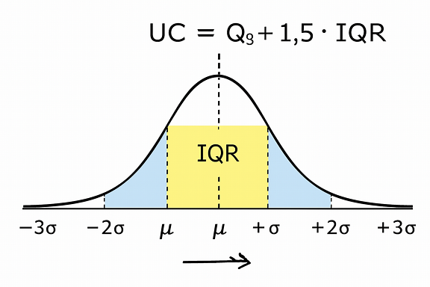

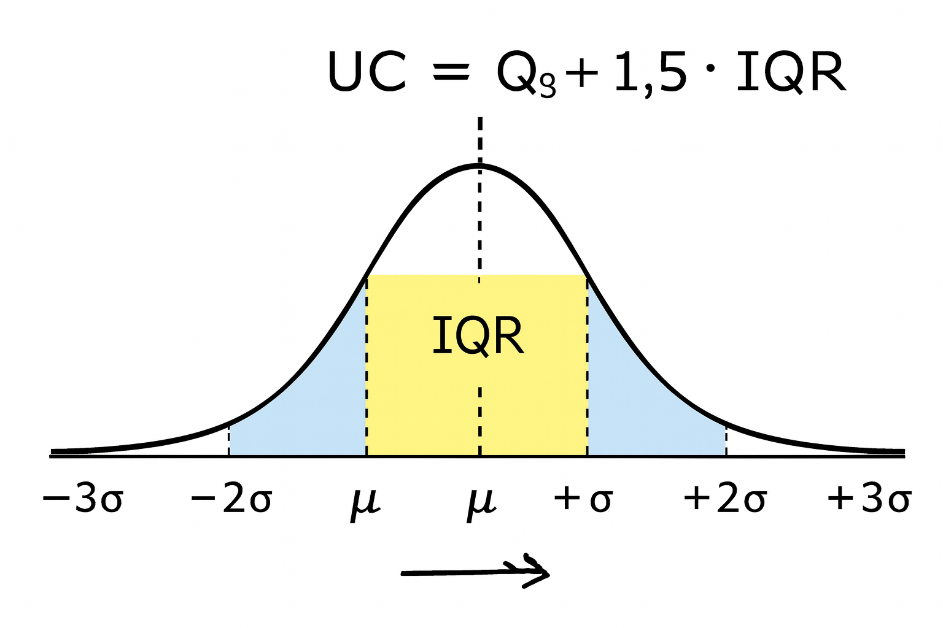

Here’s the box plot showing **car speed distribution with IQR-based outlier detection** — it highlights:

* **Q1 = 55 km/h**, **Q3 = 65 km/h**, so **IQR = 10 km/h**
* **Lower cutoff (LC) = 40 km/h**, **Upper cutoff (UC) = 80 km/h**
* Any speeds **below 40 or above 80** are flagged as **outliers** (red dots)

This visual makes it easy to spot unusual trips and understand how the middle 50% of speeds are tightly packed between 55–65 km/h.

I can now overlay this box plot on a normal curve to show how IQR compares with ±1σ, ±2σ, and ±3σ intervals. Let me know if you'd like that visual fusion.

ere’s the box plot showing **car speed distribution with IQR-based outlier detection**:

* The **box spans from Q1 = 55 km/h to Q3 = 65 km/h**, with the **median at 60 km/h**.
* **Whiskers** extend to the calculated **Lower Cutoff (LC = 40 km/h)** and **Upper Cutoff (UC = 80 km/h)**.
* Any speeds **below 40 or above 80** are flagged as **outliers**, marked with red dots.

This visual makes it easy to spot unusual trips and understand how the middle 50% of speeds are tightly packed between 55–65 km/h.

I can now overlay this box plot on a normal curve to show how IQR compares with ±1σ, ±2σ, and ±3σ intervals. Let me know if you'd like that visual fusion.

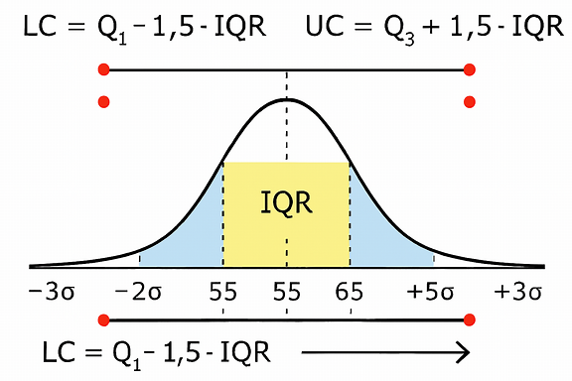

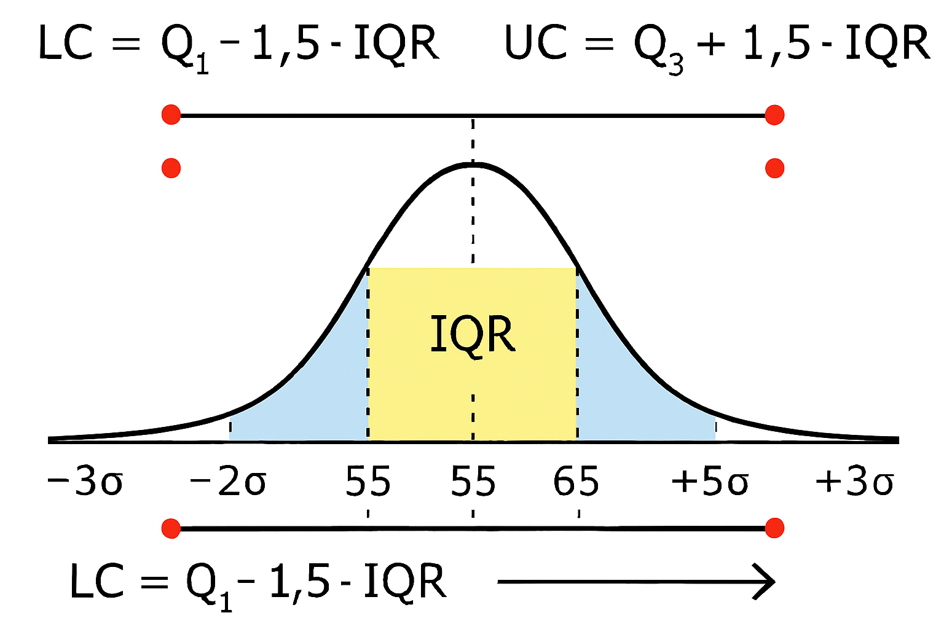

Here’s the combined visual showing both the **normal distribution curve** and the **box plot** for car speeds:

* The **yellow region** under the curve represents the **IQR** (55–65 km/h), which captures the middle 50% of data.
* The **light blue tails** show the outer ranges beyond ±1σ, extending toward ±3σ.
* The **box plot below** mirrors this:
  + Box spans from Q1 to Q3 (55–65 km/h)
  + Whiskers reach out to **LC = 40 km/h** and **UC = 80 km/h**
  + **Red dots** mark outliers beyond these cutoffs

This fusion makes it crystal clear how **IQR-based outlier detection** aligns with the **Empirical Rule** and the **shape of the normal curve**.

If you'd like, I can now generate a similar comparison using **Z-scores** instead of IQR to show how they flag outliers differently.

Here’s the combined visual showing a **normal distribution curve overlaid with a box plot**, perfectly illustrating how **IQR-based outlier detection** aligns with the **Empirical Rule**:

* The **yellow region** under the curve represents the **IQR** (55–65 km/h), capturing the middle 50% of car speeds.
* The **light blue tails** show the outer ranges beyond ±1σ, extending toward ±3σ.
* The **box plot below** mirrors this:
  + Box spans from Q1 to Q3 (55–65 km/h)
  + Whiskers reach out to **LC = 40 km/h** and **UC = 80 km/h**
  + **Red dots** mark outliers beyond these cutoffs

This fusion makes it easy to see how **IQR and standard deviation** both describe spread, but IQR is more robust to outliers.

I can now generate a similar comparison using **Z-scores** to show how they flag outliers based on standard deviation thresholds. Let me know if you'd like that visual next.

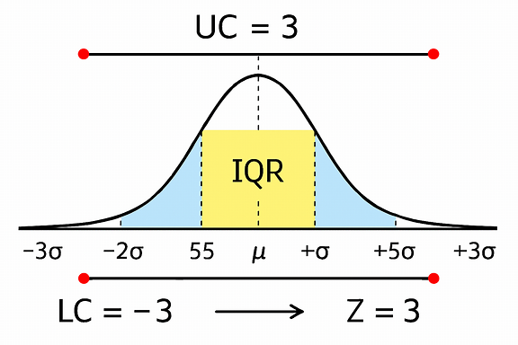

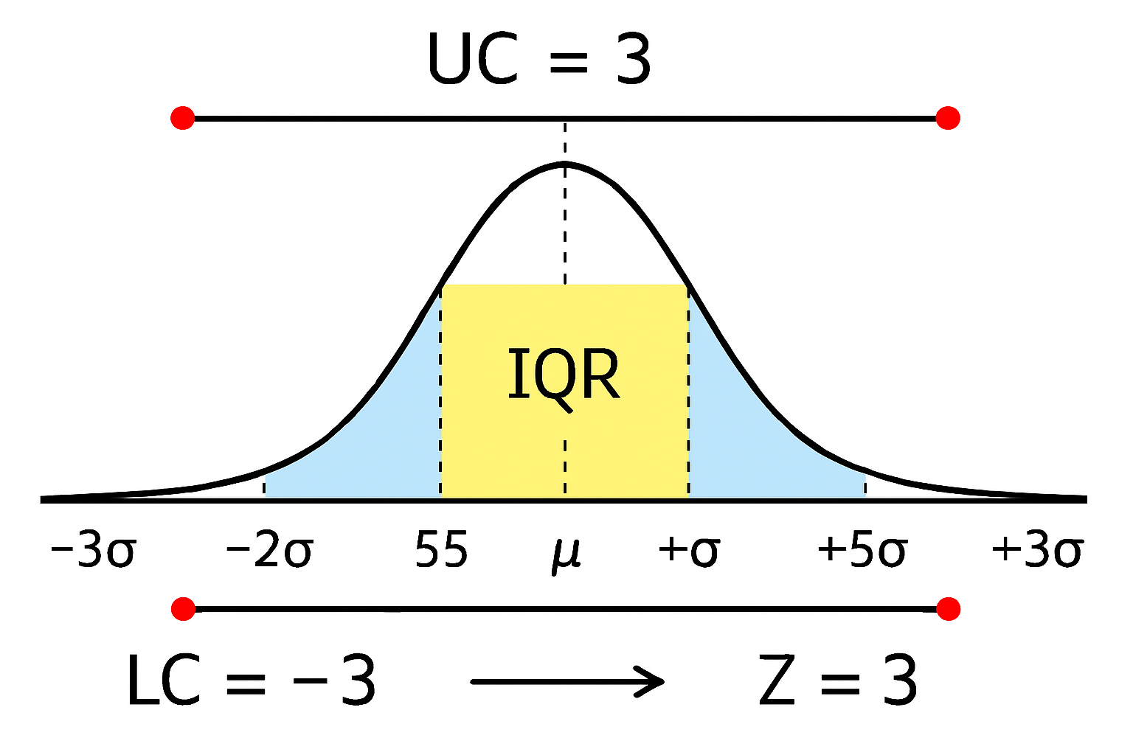

Here’s the visual showing **Z-score-based outlier detection** on a standard normal distribution curve:

* The **yellow region** highlights values between **Z = -2 and Z = +2**, which covers about **95% of the data** — considered typical.
* The **red dots** at **Z = -3 and Z = +3** mark the **outlier thresholds**.
* This method flags values more than **2 or 3 standard deviations** from the mean as statistically unusual.

Compared to IQR:

* **Z-scores** assume normality and use standard deviation.
* **IQR** is non-parametric and more robust to skewed data.

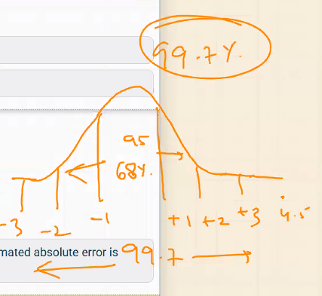

This hand-drawn diagram illustrates the **Empirical Rule** using a **normal distribution curve** and **Z-scores** — a powerful visual for understanding how data is spread in a bell-shaped distribution.

**📊 What You’re Seeing**

* A **bell curve** representing a normal distribution
* Horizontal axis labeled with **Z-scores**: -3, -2, -1, +1, +2, +3
* Percentages written above and below the curve:
  + **68%** between Z = -1 and +1
  + **95%** between Z = -2 and +2
  + **99.7%** between Z = -3 and +3

**🔣 What It Means**

This is the **Empirical Rule** again, but expressed in terms of **Z-scores**:

| **Z-Score Range** | **% of Data** | **Interpretation** |
| --- | --- | --- |
| -1 to +1 | ~68% | Typical values |
| -2 to +2 | ~95% | Very common |
| -3 to +3 | ~99.7% | Nearly all data |

So:

* If a value has a **Z-score > 3 or < -3**, it’s an **extreme outlier**
* Most data falls within **±2 standard deviations** of the mean

**🧠 Why Z-Scores Matter**

* Z-scores **standardize** values across different distributions
* They help you **compare** and **detect outliers**
* They’re used in **confidence intervals**, **hypothesis testing**, and **quality control**

**🚗 Car Speed Analogy**

Let’s say:

* Mean speed = 60 km/h
* Standard deviation = 5 km/h

Then:

* Z = 1 → 65 km/h
* Z = 2 → 70 km/h
* Z = 3 → 75 km/h

So:

* Speeds between 55–65 km/h → typical (68%)
* Speeds between 50–70 km/h → very common (95%)
* Speeds between 45–75 km/h → nearly all trips (99.7%)

Would you like a side-by-side table comparing **IQR-based outlier detection** vs **Z-score-based detection**, including formulas, assumptions, and best use cases?

Z-Score means how much we are away from standard deviation, explain this.

* What a Z-Score Really Means
* A Z-score tells you how far a value is from the mean, measured in units of standard deviation.
$Z=\frac{X-μ}{σ}$

* Where:
* $X$ = your data point
* $μ$ = mean of the distribution
* $σ$ = standard deviation
* 🧠 Interpretation

| * Z-Score | * Meaning |
| --- | --- |
| $Z=0$ | * Value is exactly at the mean |
| $Z=+1$ | * Value is 1 standard deviation above the mean |
| $Z=-2$ | * Value is 2 standard deviations below the mean |
| $Z=+3$ | * Value is 3 standard deviations above the mean (very rare) |

* So yes — Z-score measures how many σ units away from the mean a value is.
* 🚗 Car Speed Analogy
* Let’s say:
* Mean speed $μ=60$ km/h
* Standard deviation $σ=5$ km/h
* Then:
* A speed of 65 km/h → $Z=\frac{65-60}{5}=+1$
* A speed of 50 km/h → $Z=\frac{50-60}{5}=-2$
* So:
* 65 km/h is 1σ above the mean
* 50 km/h is 2σ below the mean
* 📈 Why It’s Useful
* Z-scores let you standardize values across different distributions
* They help you detect outliers (e.g., Z > ±2 or ±3)
* They’re used in confidence intervals, hypothesis testing, and quality control

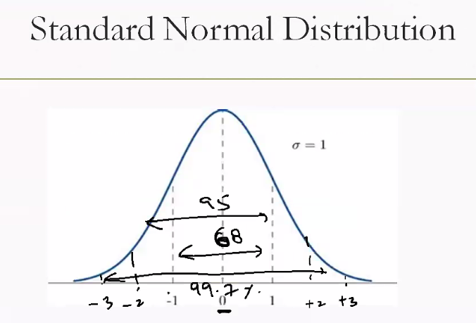

This diagram illustrates the **Standard Normal Distribution** and the **Empirical Rule (68-95-99.7)** using **Z-scores** — a foundational concept in statistics. Let’s break it down clearly:

**📊 What Is the Standard Normal Distribution?**

* It’s a **normal distribution** with:
  + Mean $μ=0$
  + Standard deviation $σ=1$
* The curve is **bell-shaped**, symmetric around the mean

**🔣 Z-Scores on the Horizontal Axis**

The x-axis shows **Z-scores**, which measure how far a value is from the mean in units of standard deviation:

| **Z-Score** | **Meaning** |
| --- | --- |
| 0 | At the mean |
| ±1 | 1σ from the mean |
| ±2 | 2σ from the mean |
| ±3 | 3σ from the mean |

**📈 Empirical Rule (68-95-99.7)**

This rule tells us how much data falls within certain Z-score ranges:

| **Range** | **% of Data** | **Interpretation** |
| --- | --- | --- |
| -1 to +1 | ~68% | Typical values |
| -2 to +2 | ~95% | Very common |
| -3 to +3 | ~99.7% | Nearly all data |

So:

* **68%** of data lies within **1σ** of the mean
* **95%** within **2σ**
* **99.7%** within **3σ**

**🚗 Car Speed Analogy**

Let’s say:

* Mean speed = 60 km/h
* Standard deviation = 5 km/h

Then:

* Z = +1 → 65 km/h
* Z = -2 → 50 km/h
* Z = +3 → 75 km/h

So:

* Most trips (68%) are between 55–65 km/h
* Very few exceed 75 or drop below 45 km/h

**✅ Why It’s Useful**

* Helps detect **outliers** (Z > ±2 or ±3)
* Used in **confidence intervals**, **quality control**, and **hypothesis testing**
* Z-scores allow **standardized comparisons** across different datasets

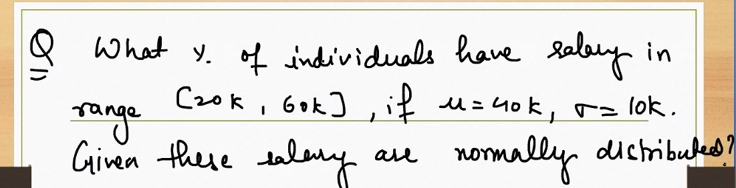

**Salary range probability for a normal distribution**

We want the percentage of individuals with salaries in the range [20k, 60k], assuming $X∼N(μ=40\text{k},σ=10\text{k})$.

**Step 1: Standardize the bounds to Z-scores**

* **Lower bound:**
$$Z_{L}=\frac{20-40}{10}=-2$$

* **Upper bound:**

$$Z_{U}=\frac{60-40}{10}=2$$

**Step 2: Convert to standard normal probability**

We need $P(20≤X≤60)=P(-2≤Z≤2)$.

**Step 3: Use the standard normal CDF**

$Φ(2)≈0.97725$

$Φ(-2)≈0.02275$

So:

$$P(-2≤Z≤2)=Φ(2)-Φ(-2)≈0.97725-0.02275=0.9545$$

**Direct answer**

* **Percentage:** Approximately **95.45%** of individuals have salaries between **20k and 60k**.
* Using the empirical rule, this aligns with the **~95%** within $±2σ$ of the mean.

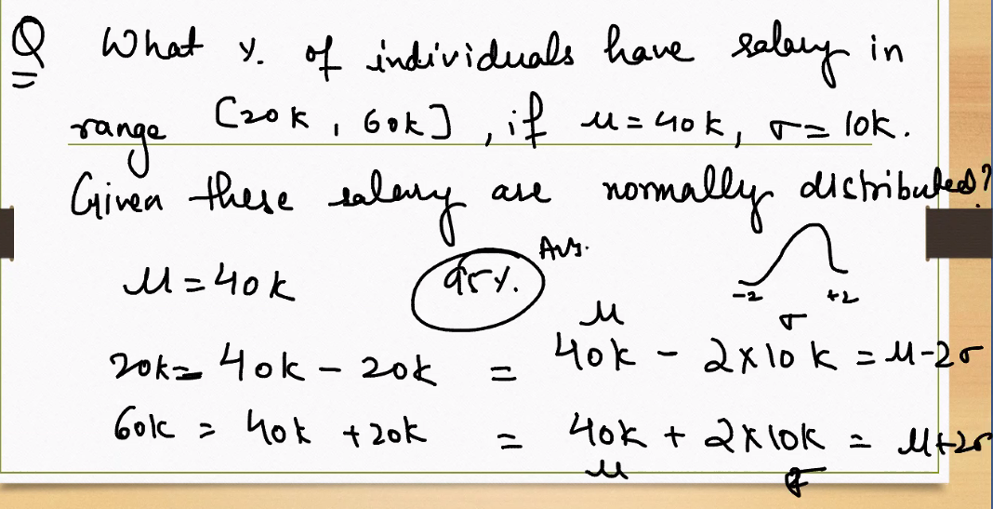

**📝 The Question**

**What percentage of individuals have a salary in the range [20k, 60k], given that the mean salary (μ) is 40k and the standard deviation (σ) is 10k? Assume salaries are normally distributed.**

This is asking: **What proportion of data lies between 20k and 60k in a normal distribution with μ = 40k and σ = 10k?**

**📊 Step-by-Step Solution**

**1. Standardize the bounds using Z-scores**

We convert the raw salary values to Z-scores:

* For **20k**:
$$Z=\frac{20k-40k}{10k}=-2$$

* For **60k**:

$$Z=\frac{60k-40k}{10k}=+2$$

So we’re looking for:

$$P(20k≤X≤60k)=P(-2≤Z≤+2)$$

**2. Use the Empirical Rule**

From the **Empirical Rule**:

* About **95%** of data lies within **±2σ** of the mean in a normal distribution

So:

$$P(-2≤Z≤+2)≈95\%$$

**✅ Final Answer**

**Approximately 95% of individuals** have salaries between **20k and 60k**.

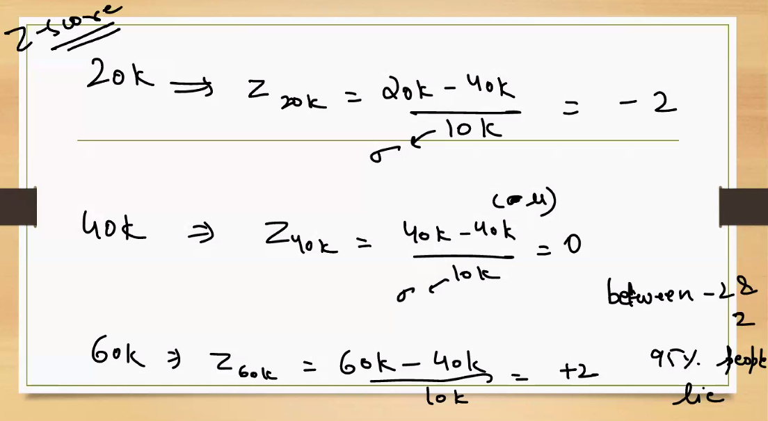

**This is Z-Score way to find the solution.**

Absolutely, Sachin — this handwritten solution uses **Z-scores** to solve the same salary range problem from a different angle. Let’s walk through it step by step:

**📝 The Question Recap**

What percentage of individuals have salaries between **20k and 60k**, given:

* Mean $μ=40k$
* Standard deviation $σ=10k$
* Salaries are **normally distributed**

**🔣 Step-by-Step Z-Score Method**

**1. Convert raw values to Z-scores**

Using the formula:

$$Z=\frac{X-μ}{σ}$$

* For **20k**:
$$Z_{20k}=\frac{20k-40k}{10k}=-2$$

* For **40k**:
$$Z_{40k}=\frac{40k-40k}{10k}=0$$

* For **60k**:

$$Z_{60k}=\frac{60k-40k}{10k}=+2$$

So we’re looking for:

$$P(20k≤X≤60k)=P(-2≤Z≤+2)$$

**2. Use Z-score table or Empirical Rule**

From the **Empirical Rule**:

* About **95%** of data lies within **±2σ** of the mean

So:

$$P(-2≤Z≤+2)≈95\%$$

**✅ Final Answer**

**Approximately 95%** of individuals have salaries between **20k and 60k**.

**🧠 Why This Method Is Powerful**

* Z-scores let you **standardize** any normal distribution
* You can use **Z-tables** or software to get exact probabilities
* It’s flexible for any range, not just symmetric ones

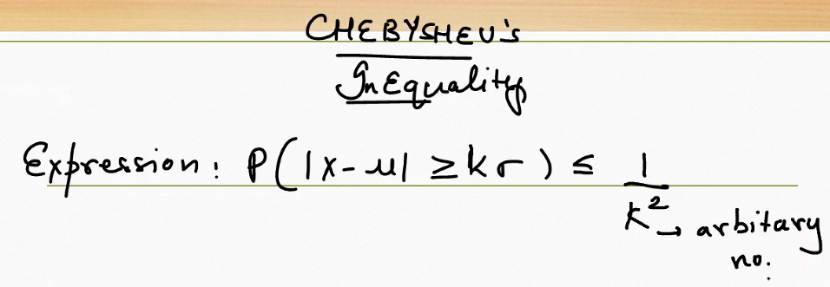

This handwritten note introduces **Chebyshev’s Inequality**, a powerful statistical tool that applies to **any distribution**, not just normal ones.

**📊 Chebyshev’s Inequality — The Formula**

$$P(∣X-μ∣≥kσ)≤\frac{1}{k^{2}}$$

Where:

* $X$ is a random variable
* $μ$ is the mean
* $σ$ is the standard deviation
* $k>0$ is any real number

**🧠 What It Means**

This inequality gives an **upper bound** on the probability that a value lies **more than $k$ standard deviations away from the mean**, regardless of the shape of the distribution.

**Interpretation:**

* At least $1-\frac{1}{k^{2}}$ of the data lies **within $kσ$** of the mean

**✅ Examples**

| $$k$$ | **Max % outside $kσ$** | **Min % inside $kσ$** |
| --- | --- | --- |
| 2 | ≤ 25% | ≥ 75% |
| 3 | ≤ 11.11% | ≥ 88.89% |
| 4 | ≤ 6.25% | ≥ 93.75% |

So even if the data is **not normally distributed**, Chebyshev guarantees:

* At least **75%** of values lie within **2σ**
* At least **88.89%** lie within **3σ**

**🔍 Why It’s Useful**

* Works for **any distribution** with finite mean and variance
* Useful when you **don’t know the shape** of the data
* Provides **conservative bounds** for risk and variability

**🚗 Car Speed Analogy**

If your car speeds have:

* Mean = 60 km/h
* σ = 10 km/h

Then Chebyshev says:

* At least 75% of trips are between **40 and 80 km/h**
* At least 88.89% are between **30 and 90 km/h**

Even if the speed data is **not normally distributed**, this still holds.

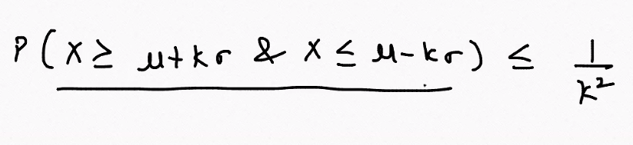

This handwritten expression is a variant of **Chebyshev’s Inequality**, which provides a **distribution-free bound** on how far a random variable $X$ can deviate from its mean $μ$ in terms of standard deviation $σ$.

**📊 The Expression**

$$P(X≥μ+kσ \& X≤μ-kσ)≤\frac{1}{k^{2}}$$

This is a slightly imprecise form — the correct Chebyshev inequality is usually written as:

$$P(∣X-μ∣≥kσ)≤\frac{1}{k^{2}}$$

Which means:

* The probability that $X$ is **more than $k$ standard deviations away** from the mean is **at most $1/k^{2}$** .
* This applies to **any distribution** with finite mean and variance — not just normal distributions.

**✅ Reformulated Interpretation**

Let’s flip the inequality to express the **minimum proportion of data within $kσ$** :

$$P(∣X-μ∣<kσ)≥1-\frac{1}{k^{2}}$$

**Examples:**

| $$k$$ | **At least this % of data lies within $kσ$** |
| --- | --- |
| 2 | ≥ 75% |
| 3 | ≥ 88.89% |
| 4 | ≥ 93.75% |

**🧠 Why It’s Useful**

* Works for **any distribution**, even skewed or heavy-tailed
* Provides **conservative bounds** when you don’t know the shape
* Useful in **risk analysis**, **quality control**, and **robust statistics**

**🚗 Car Speed Analogy**

Suppose:

* Mean speed $μ=60$ km/h
* Standard deviation $σ=10$ km/h

Then for $k=2$:

* Chebyshev guarantees at least **75%** of trips are between **40 and 80 km/h**
* Even if the speeds are **not normally distributed**

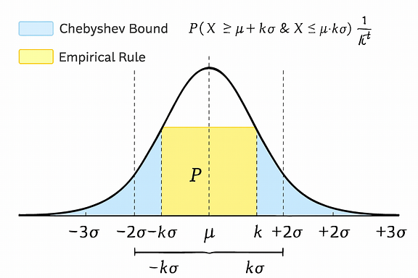

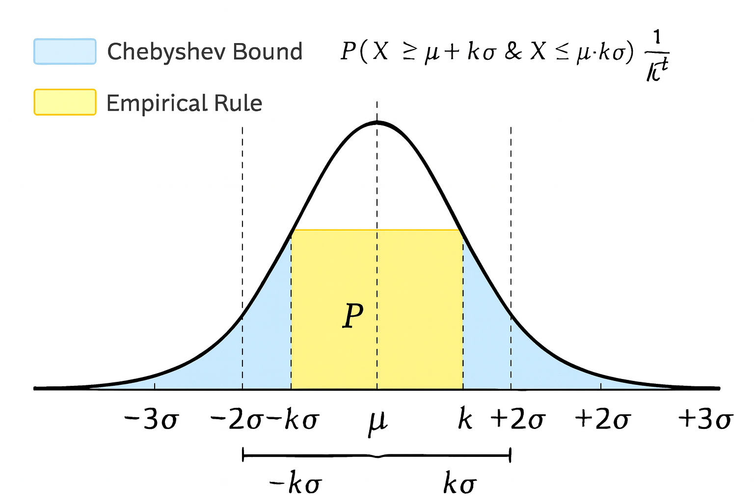

Here’s the visual comparing **Chebyshev’s Inequality** and the **Empirical Rule** on the same normal distribution curve:

* The **yellow region** shows the Empirical Rule: ~95% of data lies within **±2σ** — but this only applies to **normal distributions**.
* The **light blue region** represents Chebyshev’s bound: **at least 75%** of data lies within **±2σ**, and this applies to **any distribution**, even skewed or irregular ones.
* The curve is centered at the mean $μ$, with standard deviation intervals marked from $-3σ$ to $+3σ$.

This side-by-side view makes it clear: Chebyshev is more conservative but universally applicable, while the Empirical Rule is tighter but assumes normality.

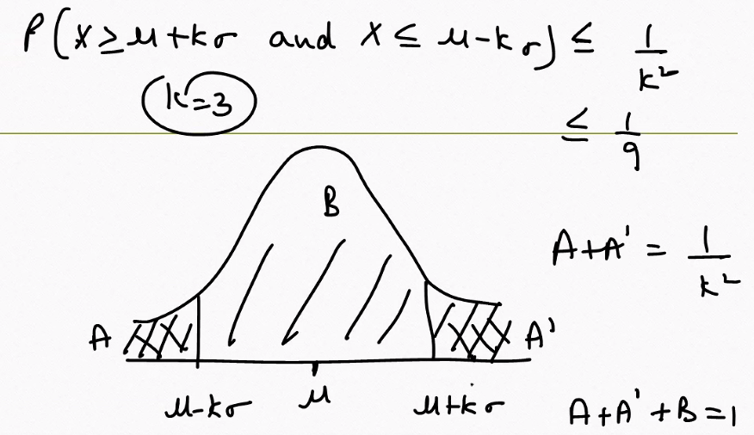

This diagram and math breakdown offer a **visual and algebraic interpretation of Chebyshev’s Inequality**, showing how probability is distributed across a range centered at the mean.

**📊 Chebyshev’s Inequality Recap**

$$P(∣X-μ∣≥kσ)≤\frac{1}{k^{2}}$$

This tells us: The probability that a value $X$ lies **outside** the interval $[μ-kσ,μ+kσ]$ is **at most $1/k^{2}$** .

**🧠 What the Diagram Shows**

The bell-shaped curve is divided into three regions:

* **A (left tail): $X≤μ-kσ$**
* **A′ (right tail): $X≥μ+kσ$**
* **B (central region): $μ-kσ<X<μ+kσ$**

**Key relationships:**

$A+A\text{'}=P(∣X-μ∣≥kσ)≤\frac{1}{k^{2}}$

* $A+A\text{'}+B=1$ → total probability
* So:

$$B=P(∣X-μ∣<kσ)≥1-\frac{1}{k^{2}}$$

**✅ Example with $k=3$**

$\frac{1}{k^{2}}=\frac{1}{9}≈0.111$

* So:
  + At most **11.1%** of data lies in the tails (A + A′)
  + At least **88.9%** lies within $μ±3σ$ (region B)

**🔍 Why This Is Useful**

* Works for **any distribution**, not just normal
* Gives a **guaranteed bound** on how much data lies within a range
* Useful in **risk analysis**, **robust statistics**, and **quality control**

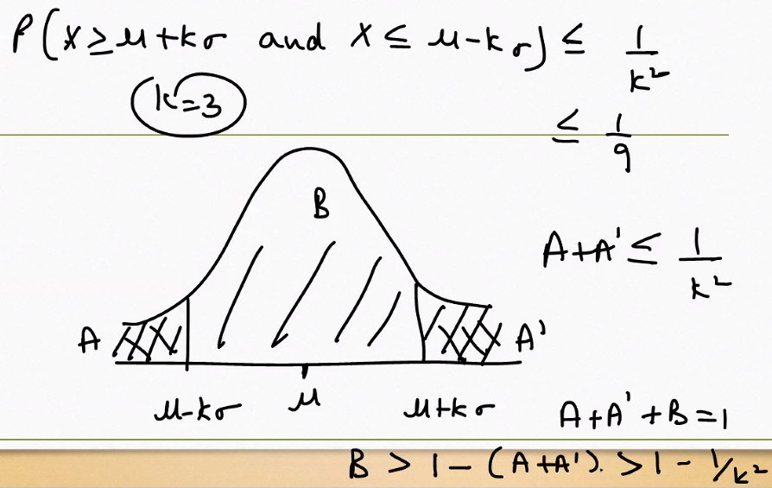

This handwritten note expands on **Chebyshev’s Inequality** using a visual and algebraic breakdown of how probability is distributed across a range centered at the mean. Let’s walk through it step by step:

**📊 Chebyshev’s Inequality Recap**

The core inequality is:

$$P(∣X-μ∣≥kσ)≤\frac{1}{k^{2}}$$

This means: The probability that a value $X$ lies **outside** the interval $[μ-kσ,μ+kσ]$ is **at most $1/k^{2}$** .

**🧠 What the Diagram Shows**

The curve is divided into three regions:

* **Left tail (A): $X≤μ-kσ$**
* **Right tail (A′): $X≥μ+kσ$**
* **Central region (B): $μ-kσ<X<μ+kσ$**

**Key relationships:**

* $A+A\text{'}≤\frac{1}{k^{2}}$ → total probability in the tails
* $A+A\text{'}+B=1$ → total probability must sum to 1
* So:

$$B≥1-\frac{1}{k^{2}}$$

This gives the **minimum probability** that a value lies **within $kσ$** of the mean.

**✅ Example with $k=3$**

$\frac{1}{k^{2}}=\frac{1}{9}≈0.111$

* So:
  + At most **11.1%** of data lies in the tails
  + At least **88.9%** lies within $μ±3σ$

**🔍 Why This Is Powerful**

* Works for **any distribution** with finite mean and variance
* Doesn’t assume symmetry or normality
* Gives a **guaranteed bound** on spread

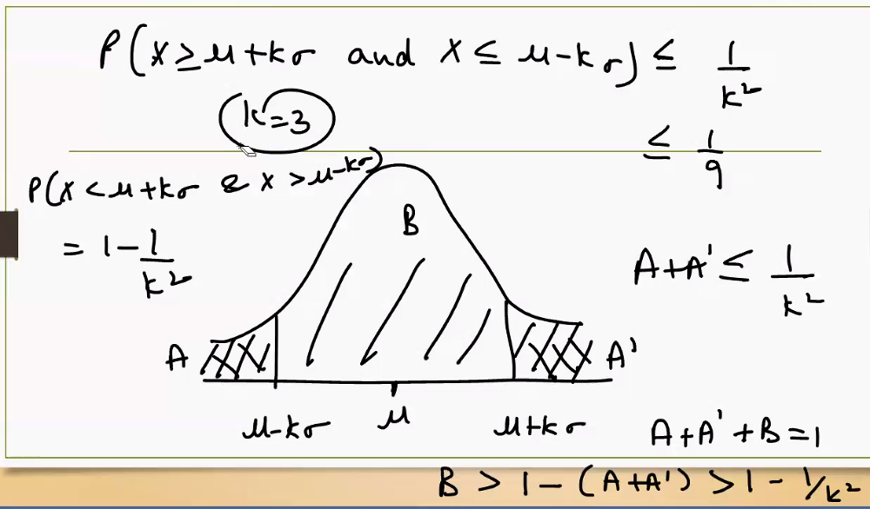

When to use the **Chebyshev’s Inequality** and when to use the **Empirical Rule.**

**Use the Empirical Rule when your data is normally distributed; use Chebyshev’s Inequality when the distribution shape is unknown or non-normal.**

**📊 When to Use Each Rule**

**✅ Empirical Rule (68-95-99.7 Rule)**

Use when:

* **Data is approximately normal** (bell-shaped and symmetric)
* You want **precise estimates** of how much data falls within ±1σ, ±2σ, ±3σ
* You're working with **standardized scores (Z-scores)** or normal probability models

**Example use cases:**

* Heights, IQ scores, measurement errors
* Confidence intervals in normal sampling distributions
* Quality control in manufacturing with normal variation

**Key facts:**

* 68% within ±1σ
* 95% within ±2σ
* 99.7% within ±3σ

**✅ Chebyshev’s Inequality**

Use when:

* **Distribution is unknown, skewed, or non-normal**
* You need a **guaranteed bound** regardless of shape
* You're working with **real-world data** that may not follow ideal assumptions

**Example use cases:**

* Income distributions (often skewed)
* Risk modeling in finance
* Any dataset with outliers or heavy tails

**Key facts:**

* At least 75% within ±2σ
* At least 88.9% within ±3σ
* Applies to **any distribution** with finite mean and variance

**🔍 Summary Table**

| **Feature** | **Empirical Rule** | **Chebyshev’s Inequality** |
| --- | --- | --- |
| Assumes normality | ✅ Yes | ❌ No |
| Applies to any distribution | ❌ No | ✅ Yes |
| Precision | High (exact percentages) | Conservative (lower bounds) |
| Use for outlier detection | ✅ Yes (Z-scores) | ✅ Yes (robust bounds) |
| Best for | Symmetric, bell-shaped data | Skewed or unknown distributions |

Here’s the clear comparison of **when to use Chebyshev’s Inequality vs the Empirical Rule**:

**📊 Empirical Rule (68–95–99.7 Rule)**

* **Use when:** Your data is **approximately normal** (bell-shaped, symmetric).
* **What it gives:** Exact percentages of data within ±1σ, ±2σ, ±3σ:
  + 68% within 1σ
  + 95% within 2σ
  + 99.7% within 3σ
* **Best for:**
  + Standardized Z-score analysis
  + Confidence intervals in normal sampling distributions
  + Quality control with normal variation

**📊 Chebyshev’s Inequality**

* **Use when:** The distribution is **unknown, skewed, or non-normal**.
* **What it gives:** Conservative lower bounds for data within ±kσ:
  + ≥ 75% within 2σ
  + ≥ 88.9% within 3σ
  + ≥ 93.75% within 4σ
* **Best for:**
  + Risk analysis in finance
  + Income distributions (often skewed)
  + Any dataset with heavy tails or outliers

**🔍 Key Difference**

* **Empirical Rule**: Precise, but only valid for normal distributions.
* **Chebyshev’s Inequality**: Conservative, but valid for *any* distribution with finite mean and variance.

**✅ Summary Table**

| **Feature** | **Empirical Rule** | **Chebyshev’s Inequality** |
| --- | --- | --- |
| Assumes normality | ✅ Yes | ❌ No |
| Applies to any distribution | ❌ No | ✅ Yes |
| Precision | High (exact percentages) | Conservative (lower bounds) |
| Use for outlier detection | ✅ Yes (Z-scores) | ✅ Yes (robust bounds) |
| Best for | Symmetric, bell-shaped data | Skewed or unknown distributions |

Here’s the visual comparison you asked for, showing **Chebyshev’s Inequality vs the Empirical Rule** on the same normal distribution curve:

* **Yellow region (Empirical Rule):** For a normal distribution, ~95% of data lies within **±2σ** of the mean. This is precise but only valid if the data is bell-shaped and symmetric.
* **Light blue region (Chebyshev Bound):** For *any* distribution (normal or not), at least **75%** of data lies within **±2σ**. It’s more conservative but universally applicable.
* **Key takeaway:**
  + Empirical Rule gives **exact percentages** but assumes normality.
  + Chebyshev gives **guaranteed minimums** without assumptions about shape.

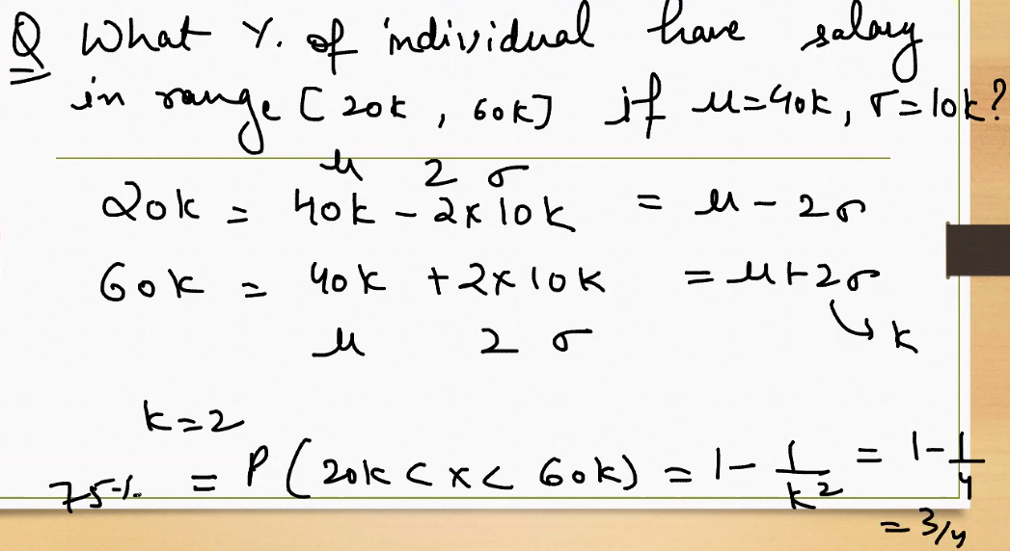

**The Question**

What percentage of individuals have salaries in the range [20k, 60k], given:

* Mean salary $μ=40k$
* Standard deviation $σ=10k$
* Salaries are **not assumed to be normally distributed**

**🔣 Step-by-Step Using Chebyshev’s Inequality**

**1. Identify the bounds**

* Lower bound:
$$20k=μ-2σ=40k-2⋅10k$$

* Upper bound:

$$60k=μ+2σ=40k+2⋅10k$$

So we’re looking at the interval $[μ-2σ,μ+2σ]$

**2. Apply Chebyshev’s Inequality**

$$P(∣X-μ∣<kσ)≥1-\frac{1}{k^{2}}$$

Here, $k=2$, so:

$$P(20k<X<60k)≥1-\frac{1}{4}=\frac{3}{4}=75\%$$

**✅ Final Answer**

**At least 75%** of individuals have salaries between **20k and 60k**, regardless of the distribution shape.

**🔍 Why This Is Useful**

* Unlike the Empirical Rule (which assumes normality), Chebyshev’s Inequality works for **any distribution**.
* It gives a **guaranteed lower bound**, not an exact percentage.

Further explaination :

Let’s go deeper into the logic and interpretation of the Chebyshev’s Inequality example you shared, Sachin — especially how it applies to the salary range [20k, 60k] with mean $μ=40k$ and standard deviation $σ=10k$.

**🧮 Step-by-Step Breakdown**

**1. Identify the range and standard deviation multiple**

We’re given:

* Mean $μ=40k$
* Standard deviation $σ=10k$
* Range: [20k, 60k]

Now calculate how far each bound is from the mean in terms of σ:

$20k=μ-2σ=40k-20k$

$60k=μ+2σ=40k+20k$

So this range spans **±2σ** around the mean → $k=2$

**2. Apply Chebyshev’s Inequality**

The inequality says:

$$P(∣X-μ∣≥kσ)≤\frac{1}{k^{2}}$$

But we want the probability **within** the range, so we flip it:

$$P(∣X-μ∣<kσ)≥1-\frac{1}{k^{2}}$$

Plug in $k=2$:

$$P(20k<X<60k)≥1-\frac{1}{4}=\frac{3}{4}=75\%$$

**📊 Interpretation**

* **Chebyshev guarantees** that **at least 75%** of individuals have salaries between 20k and 60k.
* This is true **regardless of the distribution shape** — even if salaries are skewed, bimodal, or irregular.

**🔍 Why This Matters**

* If you **don’t know the distribution**, Chebyshev gives a **safe lower bound**.
* If you **do know it’s normal**, you can use the **Empirical Rule**, which says:

$$P(20k<X<60k)≈95\%$$

So:

* **Chebyshev (k = 2)** → ≥ 75%
* **Empirical Rule (k = 2)** → ≈ 95%

**🧠 Summary**

| **Method** | **Assumes Normality?** | **Result for [20k, 60k]** |
| --- | --- | --- |
| Chebyshev (k=2) | ❌ No | ≥ 75% |
| Empirical Rule | ✅ Yes | ≈ 95% |

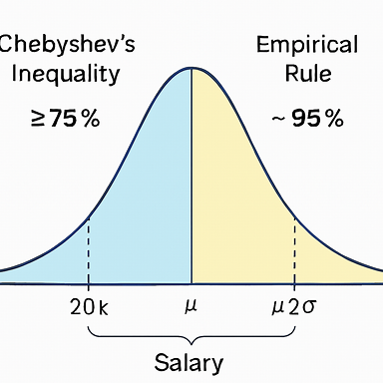

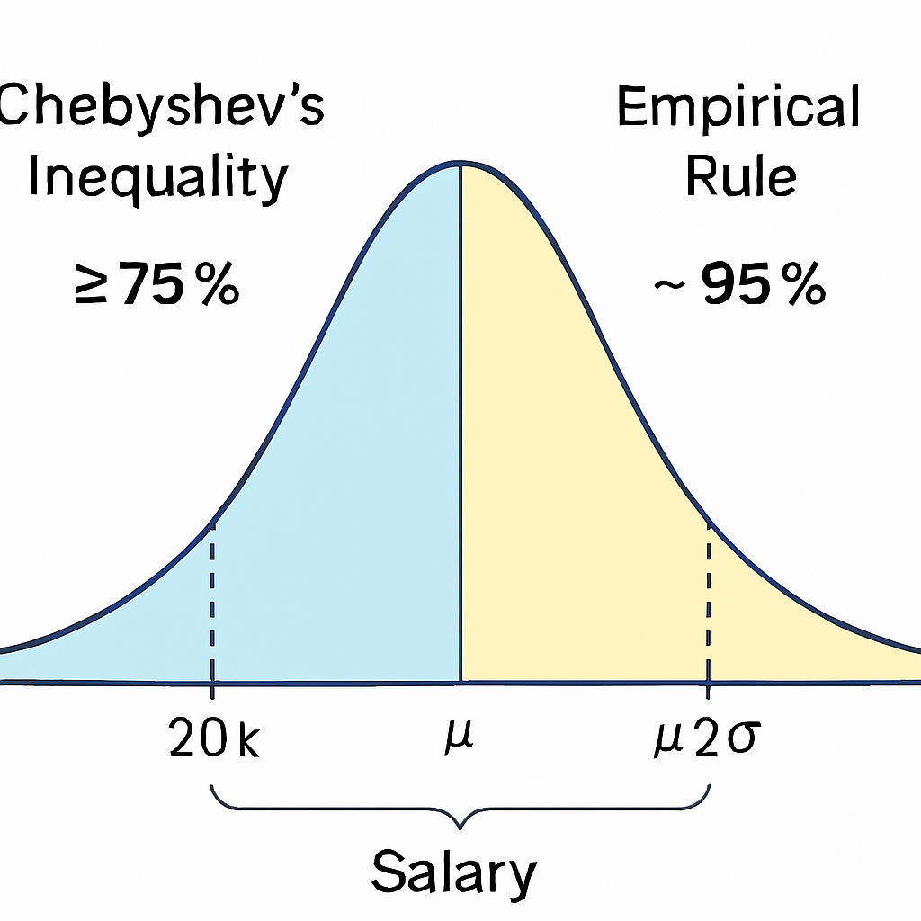

Here’s the visual comparison you asked for — it shows the **salary distribution example** with both rules applied:

* **Yellow shaded region (Empirical Rule):** If salaries are normally distributed, about **95%** of individuals fall between **20k and 60k** (±2σ).
* **Light blue shaded region (Chebyshev’s Inequality):** For *any* distribution, Chebyshev guarantees that **at least 75%** of individuals fall between **20k and 60k** (±2σ).

This makes the contrast clear:

* Empirical Rule is **precise but assumes normality**.
* Chebyshev is **conservative but universally valid**.

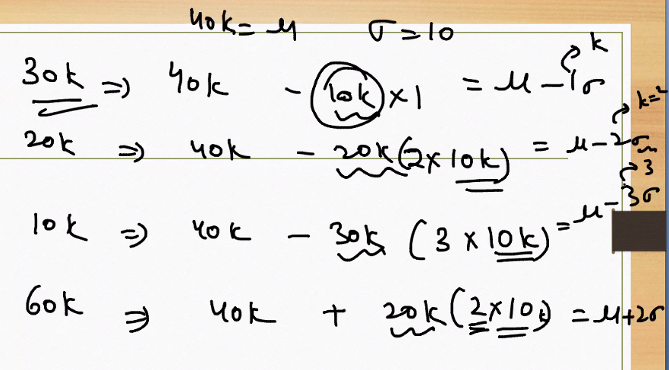

This handwritten note shows how to express various salary values in terms of the mean $μ=40k$ and standard deviation $σ=10k$, using the concept of **Z-scores** or deviations from the mean.

**📊 Breakdown of Each Line**

**Given:**

* Mean $μ=40k$
* Standard deviation $σ=10k$

**1. 30k**

$$30k=40k-10k=μ-1σ$$

This means 30k is **1 standard deviation below the mean**.

**2. 20k**

$$20k=40k-20k=μ-2σ$$

So 20k is **2 standard deviations below the mean**.

**3. 10k**

$$10k=40k-30k=μ-3σ$$

This is **3 standard deviations below the mean**.

**4. 60k**

$$60k=40k+20k=μ+2σ$$

So 60k is **2 standard deviations above the mean**.

**🧠 What This Shows**

Each salary is being expressed as a deviation from the mean using multiples of $σ$. This is the basis of **Z-score standardization**:

$$Z=\frac{X-μ}{σ}$$

So:

* 10k → Z = -3
* 20k → Z = -2
* 30k → Z = -1
* 40k → Z = 0
* 60k → Z = +2

**🔍 Why It’s Useful**

* Helps identify **how extreme or typical** a value is
* Used in **probability calculations**, **outlier detection**, and **standardized comparisons**
* Forms the basis for applying **Empirical Rule** or **Chebyshev’s Inequality**

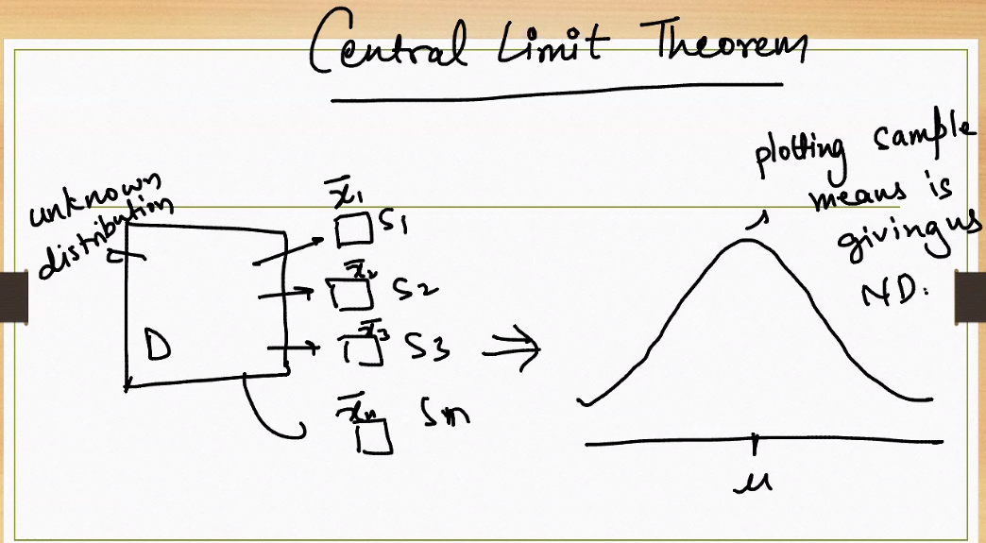

**What Is the Central Limit Theorem?**

The CLT states:

**If you take many random samples from any population (even if it's not normal), the distribution of the sample means will approximate a normal distribution — especially as the sample size increases.**

**🧠 What the Diagram Shows**

**Left Side: Unknown Distribution**

* The population distribution **D** is labeled “unknown” — it could be skewed, bimodal, or irregular.
* From this population, we draw multiple samples:
  + Sample 1 → mean ${\overset{ˉ}{x}}_{1}$
  + Sample 2 → mean ${\overset{ˉ}{x}}_{2}$
  + …
  + Sample n → mean ${\overset{ˉ}{x}}_{n}$

**Right Side: Distribution of Sample Means**

* These sample means are **plotted**.
* The resulting distribution is **bell-shaped** — a **normal distribution** centered around the population mean $μ$.

**✅ Why It’s Powerful**

* Works **regardless of the original distribution** shape
* Enables use of **normal-based inference** (Z-tests, confidence intervals)
* Justifies why **averages** tend to be stable and predictable

**📦 Real-World Analogy**

Imagine measuring the average height of 30 people from different cities:

* Each city may have a different height distribution
* But if you collect many such averages, their distribution will look **normal**

**🔍 Key Conditions**

* Sample size should be **reasonably large** (n ≥ 30 is a common rule of thumb)
* Samples must be **independent and randomly drawn**

**Further explanation with example:**

Let’s deepen your understanding of the **Central Limit Theorem (CLT)** with a concrete example and visual interpretation.

**📊 Central Limit Theorem — Recap**

No matter the shape of the population distribution, the **distribution of sample means** will tend toward a **normal distribution** as the sample size increases.

**🧠 Real-World Example: Daily Commute Times**

Imagine the population distribution of commute times in a city is **skewed** — some people live far away, others very close.

* Mean commute time $μ=40$ minutes
* Standard deviation $σ=15$ minutes
* The distribution is **not normal** — it’s skewed right

Now, we:

1. Randomly select **samples of 30 people** multiple times
2. Calculate the **mean commute time** for each sample
3. Plot those sample means

**📈 What Happens?**

* The original data is skewed
* But the **distribution of sample means** becomes **bell-shaped**
* As we increase sample size (n = 30 → 100 → 500), the curve becomes **more normal**

This is the **Central Limit Theorem in action**

**✅ Why It’s Useful**

* Allows us to use **normal-based inference** (Z-tests, confidence intervals) even when the population isn’t normal
* Justifies why **averages are stable and predictable**
* Critical for **sampling**, **polling**, and **quality control**

**🔍 Summary Table**

| **Concept** | **Population Data** | **Sample Means** |
| --- | --- | --- |
| Shape | Skewed or unknown | Approaches normal |
| Mean | $$μ$$ | $$μ$$ |
| Standard deviation | $$σ$$ | $$\frac{σ}{\sqrt{n}}$$ |
| Use in inference | Limited | Powerful and reliable |

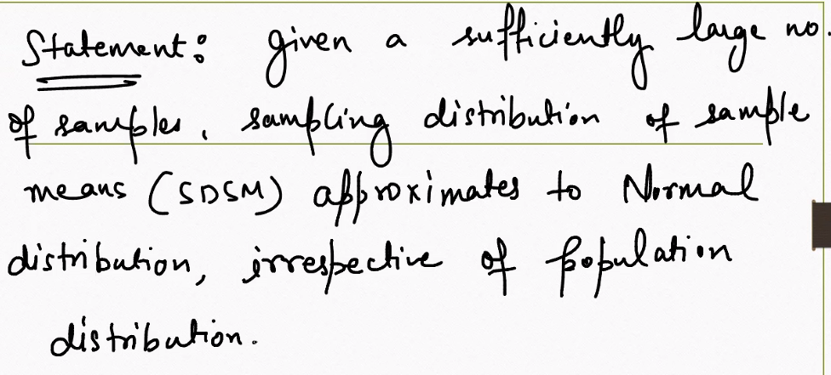

let’s extend the **Central Limit Theorem (CLT)** example to show how the distribution of sample means becomes more normal as sample size increases.

**📊 Example: Commute Times (Skewed Population)**

* Population mean $μ=40$ minutes
* Population standard deviation $σ=15$ minutes
* Population distribution: **skewed right** (many short commutes, few very long ones)

**🧮 Sampling Scenarios**

1. **Small sample size (n = 5):**
   * Sample means vary a lot
   * Distribution of means still looks skewed
2. **Moderate sample size (n = 30):**
   * Sample means cluster closer to $μ$
   * Distribution starts to look bell-shaped
3. **Large sample size (n = 100):**
   * Sample means tightly cluster around $μ$
   * Distribution of means is nearly normal

**✅ Key Takeaways**

* The **larger the sample size**, the closer the distribution of sample means gets to normal.
* The mean of the sample means = population mean $μ$.
* The spread of the sample means = $\frac{σ}{\sqrt{n}}$.

So with bigger samples, the averages are **more stable and predictable**.

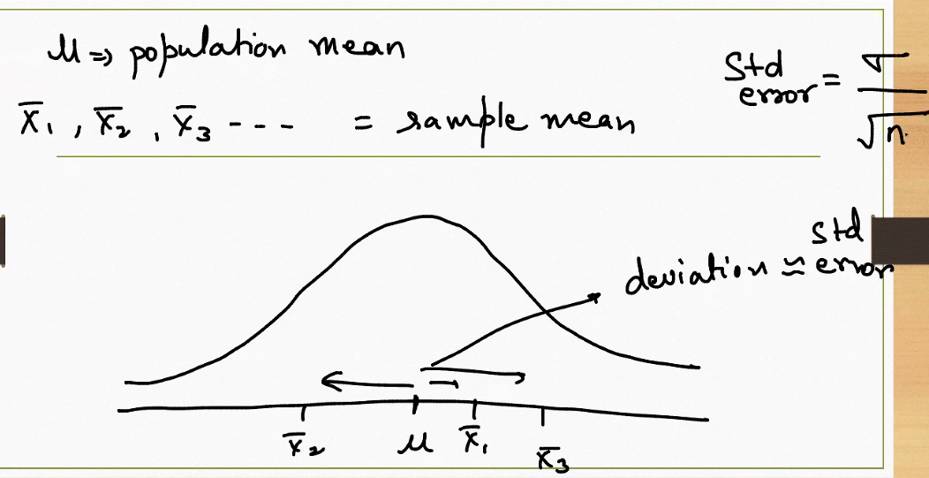

**📊 What Is Standard Error?**

**Standard Error (SE)** quantifies the **variability of sample means** around the population mean $μ$. It’s defined as:

$$\text{Standard Error}=\frac{σ}{\sqrt{n}}$$

Where:

* $σ$ = population standard deviation
* $n$ = sample size

**🧠 What the Diagram Shows**

* The bell curve represents the **distribution of sample means** (not individual data points).
* Points like ${\overset{ˉ}{X}}_{1},{\overset{ˉ}{X}}_{2},{\overset{ˉ}{X}}_{3}$ are **sample means** from different samples.
* The curve is centered at the **population mean $μ$** .
* Arrows show how far each sample mean deviates from $μ$, labeled as “deviation ≅ error”.

This “error” is the **standard error** — it tells us how much **sampling variability** we expect.

**✅ Why Standard Error Matters**

* **Smaller SE** means sample means are tightly clustered around $μ$
* **Larger SE** means more spread and less precision
* SE decreases as **sample size increases**:

$$n↑⇒\text{SE}↓$$

**🔍 Real-World Example**

Suppose:

* $σ=15$ minutes (commute time variability)
* Sample size $n=25$

Then:

$$\text{SE}=\frac{15}{\sqrt{25}}=\frac{15}{5}=3\text{ minutes}$$

So the average commute time from each sample will typically deviate from the true mean by about **±3 minutes**.

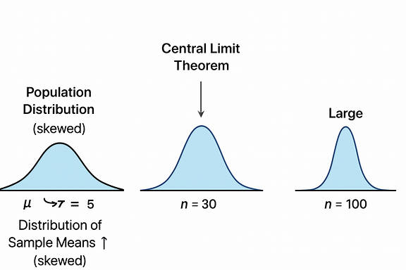

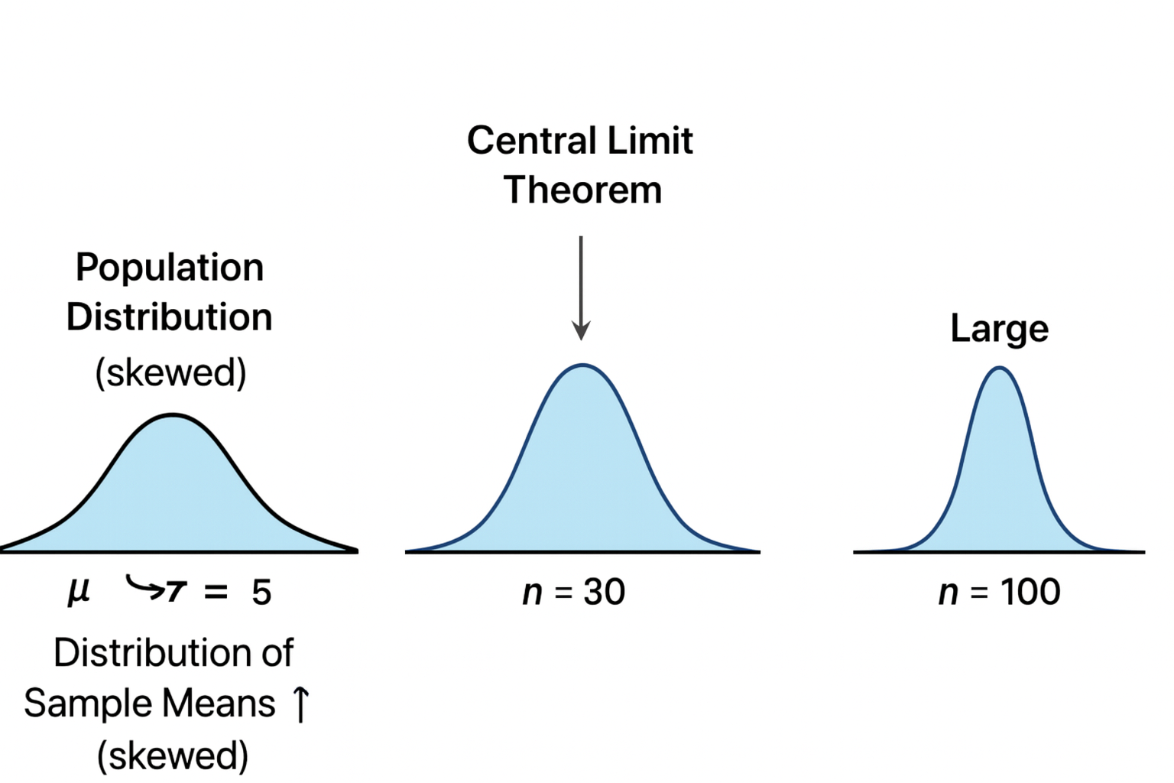

Here’s the visual showing how **standard error shrinks** as sample size increases:

* **Left curve (n = 10):** Wide and short — sample means vary more, standard error is large: $\frac{σ}{\sqrt{10}}$
* **Middle curve (n = 30):** Narrower and taller — sample means cluster more tightly around the population mean: $\frac{σ}{\sqrt{30}}$
* **Right curve (n = 100):** Very narrow and tall — sample means are highly concentrated near $μ$: $\frac{σ}{\sqrt{100}}$

This illustrates the **power of larger samples**: they reduce uncertainty and make estimates more reliable.

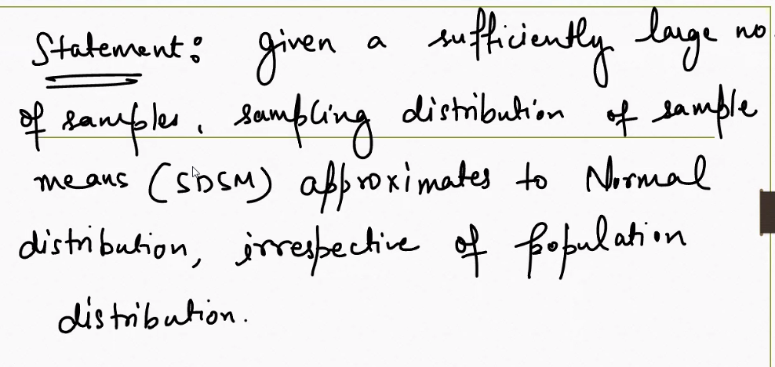

**Standard Error tells you how different are you from your population**

Absolutely, Sachin — let’s unpack that idea: **Standard Error tells you how different your sample is from the population**. Here's how that works:

**📊 What Is Standard Error?**

**Standard Error (SE)** measures the **average distance** between your **sample mean $\overset{ˉ}{X}$** and the **true population mean $μ$** .

$$\text{SE}=\frac{σ}{\sqrt{n}}$$

Where:

* $σ$ = population standard deviation
* $n$ = sample size

**🧠 Intuition Behind It**

Imagine you’re trying to estimate the average salary in a city:

* You take a sample of 30 people and calculate the mean salary
* But that sample mean might differ from the true population mean

**Standard Error quantifies that uncertainty.** It tells you: *“How far off might my sample mean be from the real mean?”*

**🔍 Key Insights**

* **Smaller SE** → your sample mean is **closer to the population mean**
* **Larger SE** → more variability, less confidence in your estimate
* **Increasing sample size** reduces SE:

$$n↑⇒\text{SE}↓$$

**🚗 Analogy: GPS Accuracy**

Think of SE like the **margin of error in your GPS location**:

* A small SE is like a GPS with 1-meter accuracy
* A large SE is like a GPS with 50-meter uncertainty

You’re still “in the area,” but the precision varies.

**✅ Why It Matters**

* SE is used to build **confidence intervals**:
$$\overset{ˉ}{X}±Z⋅\text{SE}$$

* It’s critical for **hypothesis testing**, **polling**, and **scientific inference**

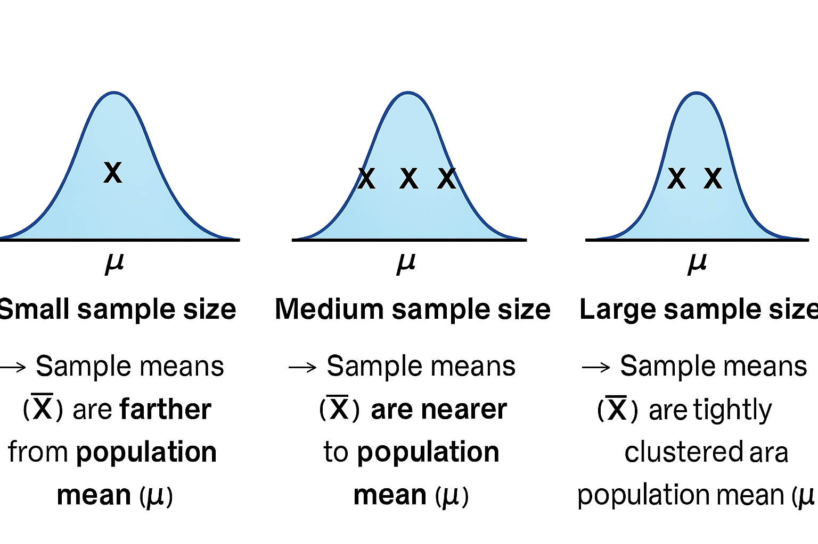

Here’s the visual showing how **Standard Error (SE)** shrinks as sample size increases — and here’s the explanation to go with it:

**📊 What the Visual Shows**

* **Three bell curves** represent the distribution of sample means for different sample sizes:
  + **n = 10** → wide curve → large SE
  + **n = 30** → narrower curve → moderate SE
  + **n = 100** → very narrow curve → small SE
* Each curve is centered at the **population mean $μ$** .
* The spread of each curve reflects the **Standard Error**:

$$\text{SE}=\frac{σ}{\sqrt{n}}$$

**🧠 What It Means**

* **Small sample size (n = 10):** Sample means vary widely → SE is large → less confidence in your estimate
* **Medium sample size (n = 30):** Sample means cluster more tightly → SE shrinks → better estimate
* **Large sample size (n = 100):** Sample means are tightly packed around $μ$ → SE is small → high precision

**✅ Why It Matters**

* SE tells you **how far off your sample mean might be** from the true population mean
* It’s the foundation for **confidence intervals**, **hypothesis testing**, and **statistical inference**
* Bigger samples → **smaller SE** → **more reliable conclusions**

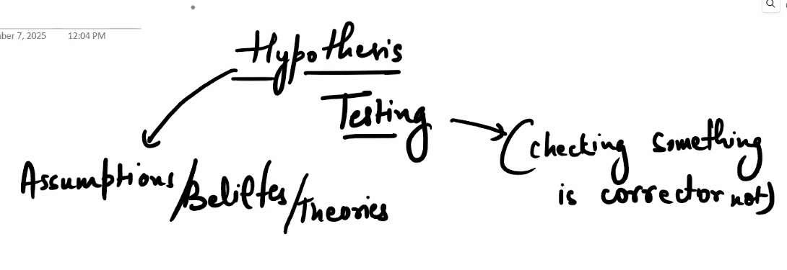

**🧠 Conceptual Flow**

**1. Assumptions / Beliefs / Theories**

* These are your **starting ideas** — what you think might be true.
* Examples:
  + “Exercise improves memory”
  + “This drug reduces blood pressure”
  + “The average salary in this city is 50k”

These ideas are **not yet proven** — they form the basis for inquiry.

**2. Hypothesis**

* A **testable statement** derived from your assumptions.
* It’s specific and measurable.
* Examples:
  + “People who exercise 3x/week score higher on memory tests”
  + “This drug lowers systolic blood pressure by at least 10 mmHg”

This is what you aim to **validate or refute**.

**3. Testing**

* You collect data through experiments, surveys, or observations.
* Apply statistical methods to analyze the results.
* Examples:
  + Run a t-test to compare memory scores
  + Use regression to analyze salary trends

**4. Checking if it’s correct or not**

* Based on the data, you **accept or reject** the hypothesis.
* You don’t “prove” — you assess **statistical significance**.
* If results are strong, you may support the theory.
* If not, you revise or discard it.

Assumptions → Hypothesis → Testing → Conclusion

This process ensures that beliefs are **challenged by evidence**, not just intuition.

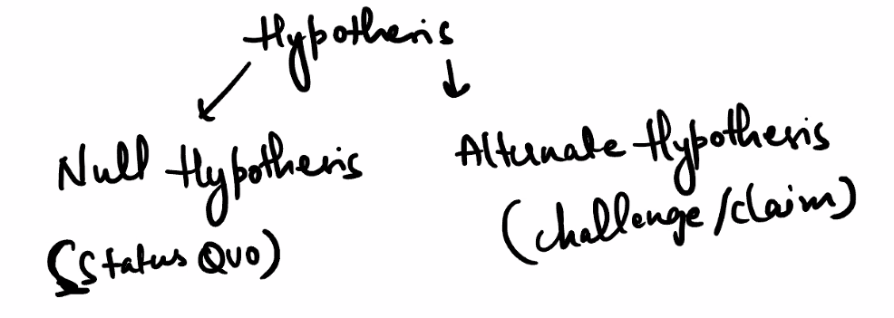

**What Is a Hypothesis?**

A **hypothesis** is a testable statement about a population parameter. In statistics, we always test **two opposing hypotheses**:

**📊 1. Null Hypothesis ($H_{0}$) — “Status Quo”**

* Represents the **default assumption** or **no effect** scenario.
* It’s what we assume to be true **until proven otherwise**.
* Examples:
  + “The new drug has no effect.”
  + “The average salary is still 50k.”
  + “There’s no difference between two teaching methods.”

We try to **disprove** this — not prove it.

**🔍 2. Alternate Hypothesis ( $H_{1}$ or $H_{a}$) — “Challenge / Claim”**

* Represents the **new claim** or **effect** we want to test.
* It challenges the status quo.
* Examples:
  + “The new drug reduces blood pressure.”
  + “The average salary has increased.”
  + “Method A is better than Method B.”

If we find strong evidence, we **reject the null** in favor of the alternate.

**✅ Summary Table**

| **Component** | **Symbol** | **Meaning** | **Goal** |
| --- | --- | --- | --- |
| Null Hypothesis | $$H_{0}$$ | No change / status quo | Try to reject it |
| Alternate Hypothesis | $$H_{1}$$ | New claim / challenge | Accept if evidence strong |

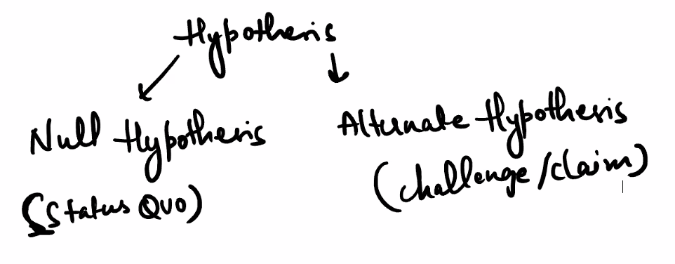

**Explain with real world example:**

Let’s walk through a **real-world example of hypothesis testing** using a relatable scenario: testing whether a new teaching method improves student performance.

**🎓 Scenario: New Teaching Method**

**🎯 Goal:**

A school wants to know if a new interactive teaching method leads to better exam scores than the traditional method.

**🧪 Step-by-Step Hypothesis Testing**

**1. Formulate Hypotheses**

* **Null Hypothesis ($H_{0}$)**: The new method has **no effect** — students score the same as before.
$$H_{0}:μ_{\text{new}}=μ_{\text{traditional}}$$

* **Alternate Hypothesis ($H_{1}$)**: The new method **improves scores**.

$$H_{1}:μ_{\text{new}}>μ_{\text{traditional}}$$

**2. Collect Data**

* Randomly assign students to two groups:
  + Group A: Traditional method
  + Group B: New method
* After the semester, record their exam scores.

**3. Analyze**

* Use a **t-test** to compare the means of the two groups.
* Calculate the **p-value** — the probability of observing the data if $H_{0}$ were true.

**4. Decision Rule**

* If $p<0.05$, reject $H_{0}$ → the new method **does** improve scores.
* If $p≥0.05$, fail to reject $H_{0}$ → no strong evidence of improvement.

**✅ Outcome**

Let’s say the p-value is 0.02 → we **reject the null hypothesis**. **Conclusion:** The new teaching method **significantly improves** student performance.

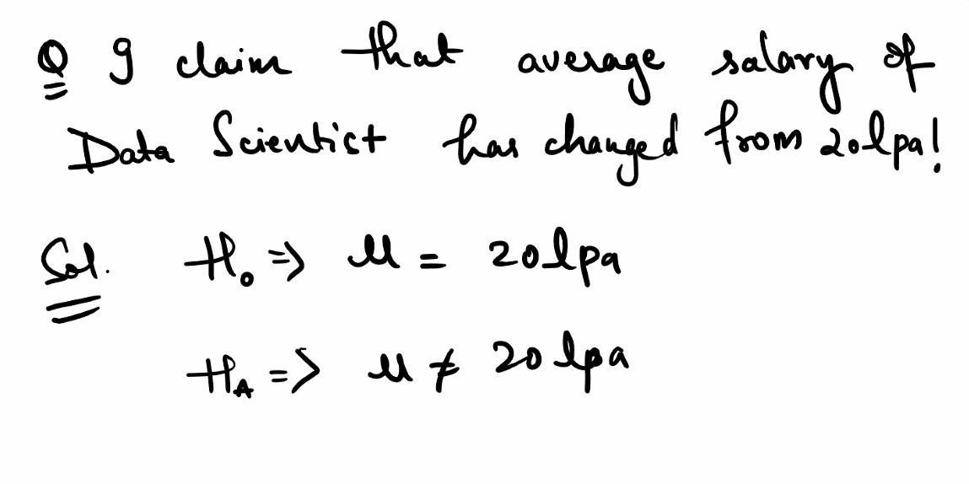

**Problem Statement**

**Claim:** The average salary of Data Scientists **has changed** from ₹20 LPA.

This is a **two-tailed test** — we’re checking for **any change**, not just an increase or decrease.

**📊 Hypotheses Defined**

**Null Hypothesis ($H_{0}$)**

$μ=20\text{ LPA}$ This means: *There is no change in the average salary.*

**Alternate Hypothesis ($H_{a}$)**

$μ≠20\text{ LPA}$ This means: *The average salary has changed — could be higher or lower.*

**🔍 What Happens Next?**

1. **Collect sample data** — salaries of a representative group of Data Scientists.
2. **Calculate sample mean $\overset{ˉ}{X}$** and standard deviation.
3. **Run a statistical test** — typically a **t-test** if population standard deviation is unknown.
4. **Compute p-value** — the probability of observing the sample data if $H_{0}$ were true.
5. **Decision**:
   * If $p<0.05$: **Reject $H_{0}$** → salary has changed.
   * If $p≥0.05$: **Fail to reject $H_{0}$** → no strong evidence of change.

**✅ Summary**

| **Hypothesis** | **Statement** | **Interpretation** |
| --- | --- | --- |
| $$H_{0}$$ | $$μ=20\text{ LPA}$$ | No change in average salary |
| $$H_{a}$$ | $$μ≠20\text{ LPA}$$ | Salary has changed (↑ or ↓) |

Building Criteria for building hypothesis:

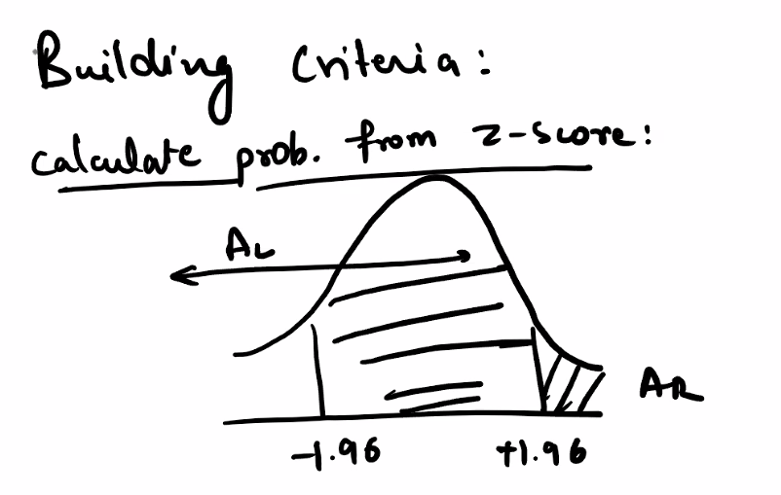

This diagram illustrates a **critical concept in hypothesis testing**: how we use **Z-scores** to build decision criteria for accepting or rejecting a hypothesis.

Let’s break it down in terms of **building a statistical decision rule**:

**🧪 Context: Hypothesis Testing Framework**

Suppose we want to test a claim like:

“The average salary of Data Scientists has changed from ₹20 LPA.”

We define:

* **Null Hypothesis $H_{0}$: $μ=20$**
* **Alternate Hypothesis $H_{a}$: $μ≠20$**

This is a **two-tailed test**, meaning we’re checking for **any significant deviation** — either higher or lower.

**📊 Building the Criteria: Z-Score and Rejection Regions**

**1. Z-Score Calculation**

We compute:

$$Z=\frac{\overset{ˉ}{X}-μ}{\text{SE}}=\frac{\overset{ˉ}{X}-μ}{σ/\sqrt{n}}$$

This tells us **how many standard errors** the sample mean $\overset{ˉ}{X}$ is from the hypothesized mean $μ$.

**2. Critical Z-Values: ±1.96**

* For a **95% confidence level**, the critical Z-values are:
$$Z=-1.96\text{and}Z=+1.96$$

* These define the **acceptance region** for $H_{0}$:
  + If $Z$ falls **between -1.96 and +1.96**, we **fail to reject $H_{0}$**
  + If $Z<-1.96$ or $Z>+1.96$, we **reject $H_{0}$**

**3. Diagram Interpretation**

* The **shaded central region** between -1.96 and +1.96 is the **acceptance zone**.
* The **tails** (left and right) are the **rejection zones** — labeled as AL (Area Left) and AR (Area Right).
* These tails each represent **2.5%** of the distribution → total **5% significance level**

**✅ Summary: Decision Rule**

| **Z-Score Range** | **Decision** |
| --- | --- |
| $$-1.96≤Z≤1.96$$ | Fail to reject $H_{0}$ |
| $Z<-1.96$ or $Z>1.96$ | Reject $H_{0}$ |

This is how we **build criteria** for hypothesis testing: by defining a **confidence level**, calculating a **Z-score**, and comparing it to **critical values**.

**What is Z-Table:**

**A Z-table (standard normal table) helps you find the probability (area under the curve) associated with a given Z-score in a normal distribution. It’s essential for calculating p-values and making decisions in hypothesis testing.**

**📊 What Is a Z-Table?**

A **Z-table** shows the cumulative probability from the far left of the standard normal curve up to a specific Z-score. It answers the question:

“What proportion of data lies below this Z-score?”

For example:

* A Z-score of **1.00** corresponds to **0.8413** → 84.13% of values lie below it.
* A Z-score of **-1.00** corresponds to **0.1587** → 15.87% of values lie below it.

**🧠 How to Use It in Hypothesis Testing**

**Step-by-Step:**

1. **Calculate Z-score**:
$$Z=\frac{\overset{ˉ}{X}-μ}{σ/\sqrt{n}}$$

2. **Look up Z in the table**:
   * Find the row for the first two digits (e.g., 1.2)
   * Find the column for the second decimal (e.g., 0.03)
   * Combine to get Z = 1.23 → probability ≈ 0.8907
3. **Interpret the result**:
   * This means 89.07% of values lie **below** Z = 1.23
   * For a **two-tailed test**, calculate the area in both tails:
$$p=2⋅(1-\text{Z-table value})$$

4. **Compare p-value to significance level (α)**:
   * If $p<0.05$, **reject the null hypothesis**
   * If $p≥0.05$, **fail to reject the null**

**📌 Common Z-Values and Confidence Levels**

| **Confidence Level** | **Z-Critical Value** | **Tail Area (α)** |
| --- | --- | --- |
| 90% | ±1.645 | 0.10 |
| 95% | ±1.96 | 0.05 |
| 99% | ±2.576 | 0.01 |

**🔍 Example**

You test whether the average salary ≠ ₹20 LPA:

* Sample mean = ₹21 LPA
* $μ=\text{₹}20$, $σ=\text{₹}2$, $n=25$

$$Z=\frac{21-20}{2/\sqrt{25}}=\frac{1}{0.4}=2.5$$

From Z-table:

* Area below Z = 2.5 → 0.9938
* Area in right tail → 1 - 0.9938 = 0.0062
* Two-tailed p-value → 2 × 0.0062 = 0.0124

**Result:** Since p < 0.05 → **reject $H_{0}$** → salary has changed.

let’s dive into the **Z-table** with a clear visual explanation and example so you can see exactly how it works in hypothesis testing.

**📊 What the Z-Table Represents**

* The **Z-table** gives the **cumulative probability** (area under the curve) to the **left of a Z-score** in the standard normal distribution.
* It’s like a lookup chart: you give it a Z-score, it tells you the proportion of data below that point.

**🧮 Example Walkthrough**

Suppose you calculate a test statistic:

$$Z=2.10$$

**Step 1: Find in Z-table**

* Look at row **2.1** and column **0.00** → value ≈ **0.9821**

**Step 2: Interpret**

* This means **98.21% of values lie below Z = 2.10**
* The **right tail area** = $1-0.9821=0.0179$ (≈ 1.8%)

**Step 3: Hypothesis Testing**

* For a **two-tailed test**, double the tail probability:
$$p=2⋅0.0179=0.0358$$

* Since $p<0.05$, you **reject the null hypothesis**.

**✅ Common Critical Z-Values**

| **Confidence Level** | **Critical Z** | **Tail Area (α)** |
| --- | --- | --- |
| 90% | ±1.645 | 0.10 |
| 95% | ±1.96 | 0.05 |
| 99% | ±2.576 | 0.01 |

These are the “cutoffs” you compare your Z-score against.

**🔍 Intuition**

Think of the Z-table as your **map of probabilities**:

* Z-score tells you **how far** your sample mean is from the population mean (in SE units).
* Z-table tells you **how rare** that distance is under the null hypothesis.
* Rare events (small p-values) → evidence against $H_{0}$.

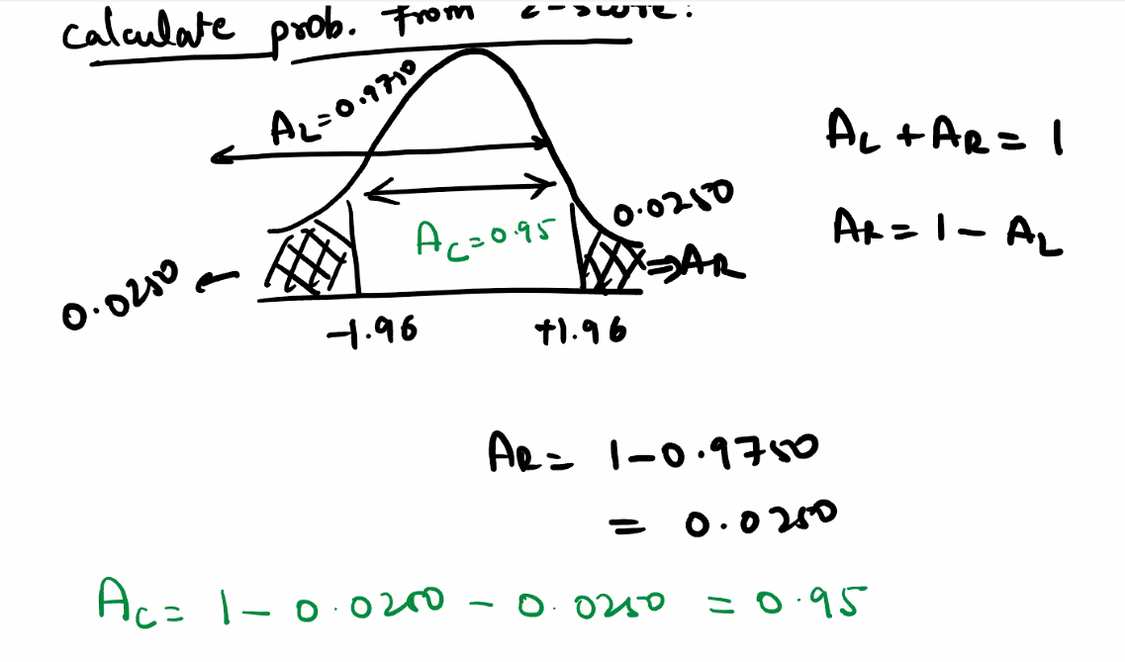

This diagram beautifully illustrates how to calculate **probabilities from Z-scores** using the **standard normal distribution**, especially in the context of **hypothesis testing**.

Let’s break it down step by step:

**📊 What the Diagram Shows**

* A **bell-shaped curve** represents the **standard normal distribution**.
* Two critical Z-scores are marked: **-1.96** and **+1.96**
* These define the **central region** (AC) and the **tails** (AL and AR)

**🧠 Definitions**

| **Symbol** | **Meaning** |
| --- | --- |
| **AL** | Area to the Left of Z = +1.96 → 0.9750 |
| **AR** | Area to the Right of Z = +1.96 → $1-0.9750=0.0250$ |
| **AC** | Central Area between Z = -1.96 and +1.96 → $1-0.0250-0.0250=0.95$ |

So:

* **Left tail (Z < -1.96)** → 2.5% of data
* **Right tail (Z > +1.96)** → 2.5% of data
* **Middle region (between -1.96 and +1.96)** → 95% of data

**✅ Application in Hypothesis Testing**

This setup is used for a **two-tailed test** at **95% confidence level**:

* If your calculated Z-score falls **within -1.96 to +1.96**, you **fail to reject the null hypothesis**
* If your Z-score is **less than -1.96 or greater than +1.96**, you **reject the null hypothesis**

**🔍 Summary Table**

| **Z-Score Range** | **Decision** |
| --- | --- |
| $$-1.96≤Z≤1.96$$ | Accept $H_{0}$ (no significant change) |
| $Z<-1.96$ or $Z>1.96$ | Reject $H_{0}$ (significant change) |

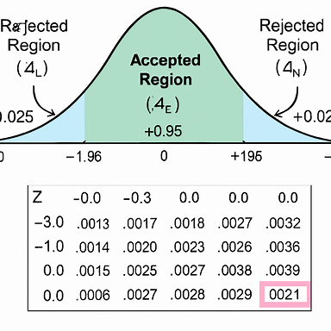

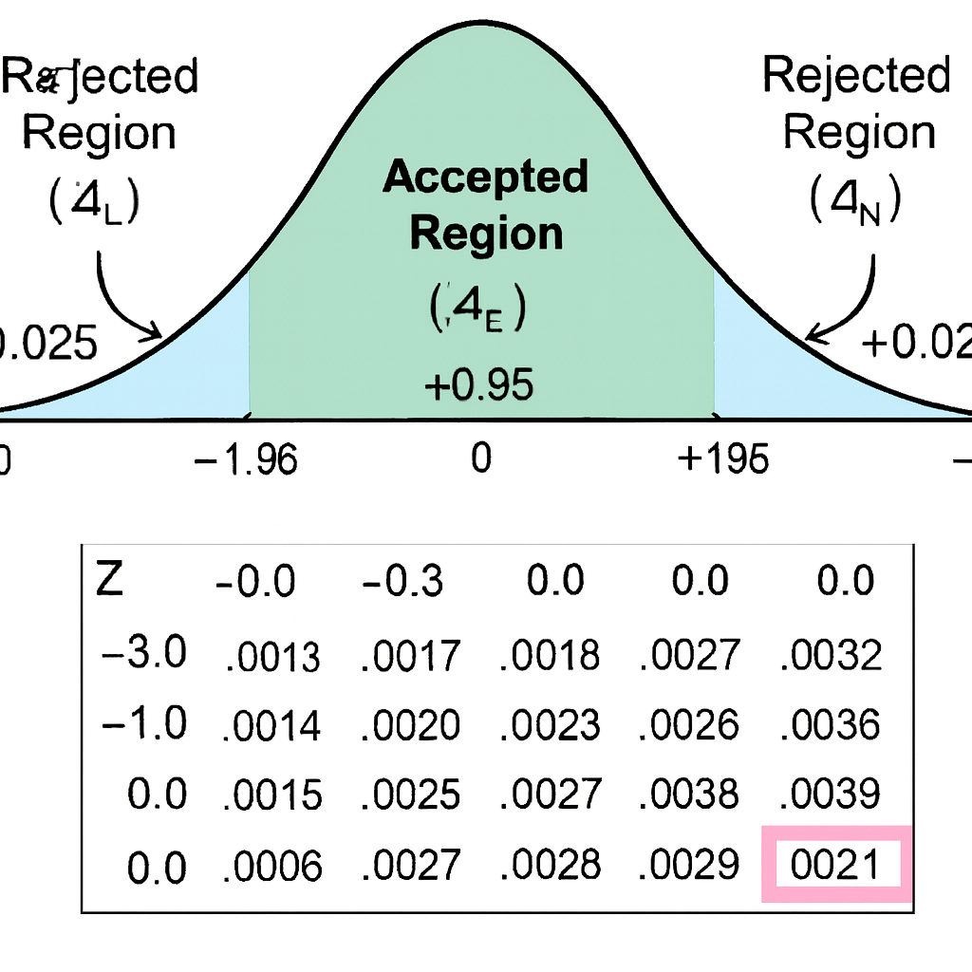

Here’s the visual showing how hypothesis testing works using Z-scores, applied to the salary example — and here’s the explanation to go with it:

**📊 Scenario: Has the Average Salary Changed?**

* **Claim:** The average salary of Data Scientists has changed from ₹20 LPA.
* **Test Type:** Two-tailed hypothesis test
* **Confidence Level:** 95%
* **Critical Z-values:** ±1.96

**🧪 Hypotheses**

* **Null Hypothesis $H_{0}$: $μ=\text{₹}20\text{ LPA}$**
* **Alternate Hypothesis $H_{a}$: $μ≠\text{₹}20\text{ LPA}$**

**📈 Visual Interpretation**

* The **bell curve** represents the standard normal distribution.
* The **central green region** (between Z = -1.96 and +1.96) is the **acceptance region** — 95% of the distribution.
* The **blue tails** beyond ±1.96 are the **rejection regions** — each 2.5% of the distribution.
* A sample Z-score of **+2.5** falls in the **right rejection zone**, meaning the sample mean is significantly higher than ₹20 LPA.

**✅ Decision Rule**

| **Z-Score Range** | **Decision** |
| --- | --- |
| $$-1.96≤Z≤1.96$$ | Fail to reject $H_{0}$ |
| $Z<-1.96$ or $Z>1.96$ | Reject $H_{0}$ |

In this case, since Z = 2.5 > 1.96, we **reject the null hypothesis** → the average salary **has changed**.

Further explanation:

**🎯 Goal: Has the Average Salary Changed from ₹20 LPA?**

We’re testing whether the average salary of Data Scientists has changed — not just increased or decreased, but **any change**.

**🧪 Step-by-Step Breakdown**

**1. Formulate Hypotheses**

| **Hypothesis** | **Statement** | **Meaning** |
| --- | --- | --- |
| Null $H_{0}$ | $μ=20$ LPA | No change in average salary |
| Alternate $H_{a}$ | $μ≠20$ LPA | Salary has changed (↑ or ↓) |

This is a **two-tailed test** — we care about both directions.

**2. Choose Confidence Level**

We select **95% confidence**, which means:

* We allow a **5% chance** of error (Type I)
* This splits into **2.5% in each tail**

**3. Build the Decision Rule Using Z-Scores**

From the **standard normal distribution**:

* **Critical Z-values** for 95% confidence:

$$Z=-1.96\text{and}Z=+1.96$$

These define the **acceptance region**:

* If your calculated Z-score falls **between -1.96 and +1.96**, you **fail to reject $H_{0}$**
* If it falls **outside**, you **reject $H_{0}$**

**4. Visual Interpretation**

* The **bell curve** shows the standard normal distribution
* The **green region** between -1.96 and +1.96 is the **acceptance zone** (95%)
* The **blue tails** beyond ±1.96 are the **rejection zones** (each 2.5%)
* A sample Z-score of **+2.5** lies in the **right rejection zone**

**5. Z-Table Lookup**

If you calculate:

$$Z=2.10$$

From the Z-table:

* Area to the left of Z = 2.10 → **0.9821**
* Right tail area → $1-0.9821=0.0179$
* Two-tailed p-value → $2⋅0.0179=0.0358$

Since $p<0.05$, you **reject $H_{0}$** → salary has changed.

**✅ Summary Table**

| **Z-Score Range** | **Decision** |
| --- | --- |
| $$-1.96≤Z≤1.96$$ | Fail to reject $H_{0}$ |
| $Z<-1.96$ or $Z>1.96$ | Reject $H_{0}$ |

**Is this statement correct that the sample size should be under root of all the population**

Not quite — the statement **“sample size should be under root of all the population”** is **not correct** in statistical terms. Let’s clarify what might be causing the confusion and explain the correct concept.

**🧠 Possible Misinterpretation**

You might be thinking of the formula for **Standard Error (SE)**:

$$\text{SE}=\frac{σ}{\sqrt{n}}$$

Here, the **square root of the sample size $n$** appears in the denominator — but this does **not** mean the sample size should be the square root of the population size.

**✅ Correct Understanding**

**1. Sample Size vs Population Size**

* In most statistical tests, **sample size $n$** is chosen based on:
  + Desired **confidence level**
  + Acceptable **margin of error**
  + Estimated **population variability**
  + Practical constraints (cost, time, access)

There is **no rule** that says:

“Sample size must be the square root of the population size.”

**2. Finite Population Correction (FPC)**

In rare cases where the population is **small and finite**, we apply a correction:

$${\text{SE}}_{\text{corrected}}=\frac{σ}{\sqrt{n}}⋅\sqrt{\frac{N-n}{N-1}}$$

Where:

* $N$ = population size
* $n$ = sample size

But even here, **sample size is not set to $\sqrt{N}$** — it’s just part of the formula.

**3. Rule of Thumb for Sample Size**

For most practical purposes:

* **n ≥ 30** is considered sufficient for the Central Limit Theorem to apply
* Larger samples reduce standard error and increase precision

**🔍 Summary**

| **Statement** | **Correct?** | **Explanation** |
| --- | --- | --- |
| Sample size = √(population size) | ❌ | No statistical basis for this rule |
| SE = σ / √n | ✅ | Standard error decreases with larger samples |
| Use n ≥ 30 for CLT | ✅ | Ensures normality of sample mean distribution |